SWMS 100 – WORK USING HAZARDOUS CHEMICALS

NOTE: This industry standard SWMS template has been made accessible by Breffni Ceilings & Partitions Pty Ltd, to be used as a guide only. The sub-contractor/user is entirely responsible for its contents at the point of submission. Therefore, please ensure that every section is reviewed and personalised in full.

- PROJECT DETAILS
Project Name: |  | Project Address:
Client / Principal Contractor:
Description of Work (Scope):
High Risk Construction Work:
Date Work is to Commence: |  | Approx. Duration of Work:
Person Responsible for Monitoring Activity: |  | Name:
Date Created: |  | Issue: | A

- CONSULTATION
THIS SWMS HAS BEEN DEVELOPED IN CONSULTATION WITH THE FOLLOWING WORKERS: |  |  |  | SWMS PROVIDED TO CLIENT / PRINCIPAL CONTRACTOR
Issue: | Name: | Position: | Date: | Issue: | Name: | Position: | Date:
A |  |  |  | A

- APPROVAL
 | APPROVED BY | REVIEWED PRIOR TO WORK COMMENCING  (Principal Contractor Representative) | REVIEWED ON SITE PRIOR TO COMMENCING WORK  (Site Supervisor)
NAME
SIGNATURE
DATE

- PERSONAL PROTECTIVE EQUIPMENT
Uniform | Footwear | High Vis’ | Safety Helmet | Protective Eyewear | Face Shield | Fall Arrest | Gloves | Hearing | Dust Mask | Respirator | Other | PPE. Notes (e.g. P2 Dust Mask, etc.)
 |  |  |  |  |  |  |  |  |  |  |  | Other mandatory site PPE as advised by Client / PC or detailed on the Safety Data Sheet.

- PERMITS, TICKETS OR LICENCES REQUIRED TO PERFORM WORK
Role / Task | Permit, Ticket or Licence

- PLANT AND EQUIPMENT
Plant and Equipment Description | Maintenance / Checks / Tests | Plant and Equipment Description | Maintenance / Checks / Tests

- CHEMICALS
Chemical Name | Hazardous? | SDS Attached | Controls
 | Yes No | Yes No | As per Safety Data Sheet
 | Yes No | Yes No
 | Yes No | Yes No
 | Yes No | Yes No
 | Yes No | Yes No
 | Yes No | Yes No
 | Yes No | Yes No

- LEGISLATION AUSTRALIAN STANDARDS AND CODES OF PRACTICE TO BE COMPLIED WITH
QUEENSLAND | NATIONAL
Work Health and Safety Act 2011 | AS/NZS 1716:2012 Respiratory protective devices
Work Health and Safety Regulation 2011 | Globally Harmonised System of Classification and Labelling of Chemicals
How to Manage Work Health and Safety Risks Code of Practice 2011
Managing Risks of Hazardous Chemicals in the Workplace Code of Practice 2013
Hazardous Manual Tasks Code of Practice 2011
Labelling of Workplace Hazardous Chemicals Code of Practice 2011
Preparation of Safety Data Sheets for Hazardous Chemicals Code of Practice 2011
WHS Consultation, Co-operation and Co-ordination Code of Practice 2011

- WORK RISKS AND CONTROLS
Item No. | Job Procedure in Steps | Possible Health, Safety and Environmental Hazards/ Risks | Risk Score Before | Health, Safety and Environmental Controls | Risk Score After | Person(s) Responsible
 | Pre-start | Workers not understanding risk controls | E 80 | Pre-start meeting with workers to discuss requirements of this SWMS.  Feedback will be requested from workers.  All workers to sign off accordingly. | M 52 | Site Supervisor
 | Using hazardous chemical | Fire  Leaks or spills  Asphyxiation  Burns  Long term illness | E 80 | Ensure a Safety Data Sheet (SDS) is available for each substance used.  Ensure the SDS is not more than five years old and meets GHS requirements.  Dispose of chemical no longer in use according to the manufacturer’s recommendations or the SDS. | L 40 | Site Supervisor
 |  | Poor understanding of chemical hazards  Failure to implement appropriate control measures | E 80 | Ensure a risk assessment for the hazardous chemical is undertaken, a safe operating procedure is developed that outlines how the substance is to be used safely and the procedure for the chemicals’ safe use is communicated, understood and followed by the employees using these hazardous chemicals.  The procedure will be monitored and periodically reviewed. | L 40 | Site Supervisor
 |  | Fire  Asphyxiation  Burns  Long term illness | E 80 | Read and follow prescribed safety procedures as stated on SDS’s.  Wear recommended PPE at all times when working with hazardous chemical.  Report symptoms resulting from the use of hazardous chemical to the Site Supervisor immediately. | M 52 | Worker
 |  | Spills | H 68 | Make sure equipment is available to clean spills up i.e. spill kit.  Clean up spills as soon as possible.  Isolate area from public or other persons.  Dispose of as directed by the SDS. | L 40 | Worker
 | Storage | Unidentified chemicals | E 80 | Ensure every chemical is clearly labelled with details of the nature and hazard of the chemical.  Do not store chemical in beverage containers. | L 40 | Worker  Site Supervisor
 |  | Reaction of incompatible goods  Fire, leaks or spills, burns | E 90 | Do not use or store incompatible goods together.  Make sure flammable, explosive or toxic chemical are stored away from possible sources of electrical spark, heat or flame. | M 52 | Worker  Site Supervisor
 | Site Emergency | Poor or delayed response in the case of emergency | E 80 | Site specific emergency procedures will be followed at all times. | L 40 | Worker  Site Supervisor

- RISK ASSESSMENT TOOL
RISK MATRIX |  |  |  |  |  |  |  |  | HIERARCHY OF CONTROLS
LIKELIHOOD |  |  | CONSEQUENCE |  |  |  |  |  | 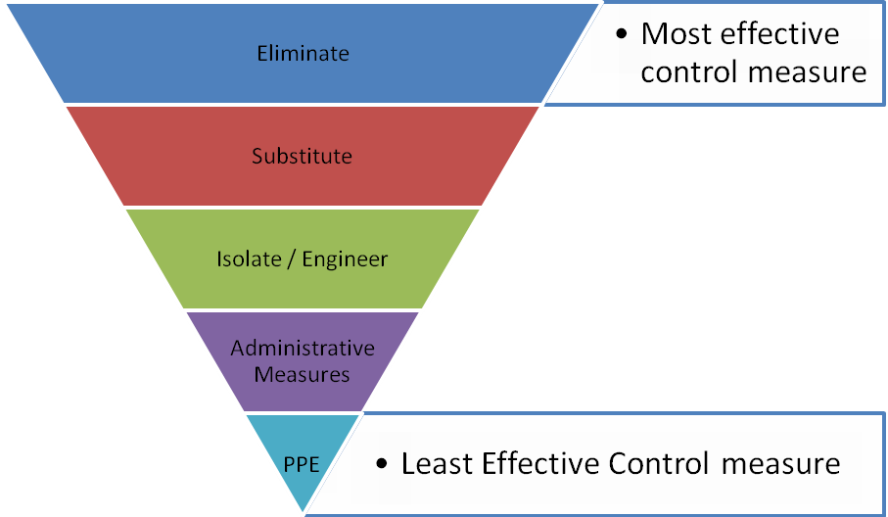
 |  |  | 1 |  | 2 | 3 | 4 | 5
 |  |  | Insignificant |  | Minor | Moderate | Major | Catastrophic
A. | Almost certain |  | M 52 |  | H 64 | E 76 | E 88 | E 100
B. | Likely |  | M 44 |  | H 56 | H 68 | E 80 | E 92
C. | Possible |  | L 36 |  | M 48 | H 60 | E 72 | E 84
D. | Unlikely |  | L 28 |  | L 40 | M 52 | H 64 | E 76
E. | Rare |  | L 20 |  | L 32 | M 44 | H 56 | H 68
SCORE INDICATOR
SCORE |  | LEVEL OF DANGER |  | REQUIRED ACTION
72 – 100 |  | EXTREME |  | NO WORK SHOULD COMMENCE AT THIS LEVEL!  This is an unacceptable level of risk. A review of controls must be performed to reduce risk as low as reasonably practicable. If risk cannot be further reduced, a Permit System must be applied. The permit must be available at all times work is being performed, signed by both the workers, a senior management representative and the Client (if applicable).
56 – 68 |  | HIGH |  | WORK CAN COMMENCE AT THIS LEVEL IF THE CONTROL MEASURES ARE APPROVED BY THE PROJECT MANAGER OR DELEGATE.  The Project Manager or delegate will review existing controls to ensure that the risk is reduced to as low as is reasonably practicable.
44 – 52 |  | MODERATE |  | WORK CAN COMMENCE WITH CONTROL MEASURES IN PLACE. Management must monitor and review the controls to ensure controls are adequately used, do not present further hazards / risks and aim to reduce the risk further if practicable.
20 - 40 |  | LOW |  | REVIEW IF CHANGES OCCUR.  Record and review if any equipment, people, materials, work processes, or procedures change.

- MONITORING AND REVIEW OF CONTROL MEASURES
Pre-Start | Pre-start meetings are held to review control measures and ensure workers are aware of controls.
Ongoing Monitoring | Site Supervisor will continually monitor works against the controls stated in this safe work method statement. The Health and Safety Checklist is used to document formal inspections of the works and work area.
Annual | This safe work method statement is reviewed annually or as required.
NON-CONFORMANCE | Should any aspect of this SWMS not be complied with, work affected by the non-compliance must cease. The Site Supervisor will either enforce the controls as stated by the SWMS or, where appropriate, review the SWMS in consultation with workers and update with more suitable controls provided the revised controls still ensure that the hazards / risks are controlled as far as reasonably practicable.

- SWMS CONSULTATION AND SIGN-OFF RECORD
I confirm, by signing below, that I have read and understand the requirements of this SWMS, that I agree that the SWMS is acceptable for the proposed work, and I agree to abide by the requirements. If the work conditions change, or additional hazards are identified, these changes shall be discussed, the SWMS modified and signed again.
ISSUE | NAME (Please Print) | SIGNATURE | ISSUE | NAME (Please Print) | SIGNATURE
A
A
A
A
A
A
A
A
A
A

