SWMS 101 – WORK AT HEIGHTS: USING FALL PREVENTION
NOTE: This industry standard SWMS template has been made accessible by Breffni Ceilings & Partitions Pty Ltd, to be used as a guide only. The sub-contractor/user is entirely responsible for its contents at the point of submission. Therefore, please ensure that every section is reviewed and personalised in full.

- PROJECT DETAILS
Project Name: |  | Project Address:
Client / Principal Contractor:
Description of Work (Scope):
High Risk Construction Work:
Date Work is to Commence: |  | Approx. Duration of Work:
Person Responsible for Monitoring Activity: |  | Name:
Date Created: |  | Issue: | A
- CONSULTATION
THIS SWMS HAS BEEN DEVELOPED IN CONSULTATION WITH THE FOLLOWING WORKERS: |  |  |  | SWMS PROVIDED TO CLIENT / PRINCIPAL CONTRACTOR
Issue: | Name: | Position: | Date: | Issue: | Name: | Position: | Date:
A |  |  |  | A

- APPROVAL
 | APPROVED BY | REVIEWED PRIOR TO WORK COMMENCING  (Principal Contractor Representative) | REVIEWED ON SITE PRIOR TO COMMENCING WORK  (Site Supervisor)
NAME
SIGNATURE
DATE

- PERSONAL PROTECTIVE EQUIPMENT
Uniform | Footwear | High Vis’ | Safety Helmet | Protective Eyewear | Face Shield | Fall Arrest | Gloves | Hearing | Dust Mask | Respirator | Other | PPE. Notes (e.g. P2 Dust Mask, etc.)
 |  |  |  |  |  | 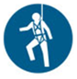 |  |  |  | 

- PERMITS, TICKETS OR LICENCES REQUIRED TO PERFORM WORK
Role / Task | Training, Permit, Ticket or Licence
Workers | Company Induction, General Construction Induction
Working from over 2 m | General Work from Heights training
Use of Fall Prevention Equipment | Use and safety measures for equipment
6 and 12 monthly Inspection of travel restraint systems | Height Safety Equipment Inspector

- PLANT AND EQUIPMENT
Plant and Equipment Description | Maintenance / Checks / Tests | Plant and Equipment Description | Maintenance / Checks / Tests
Travel restraint system | Inspected every 6 months and a written record kept for 4 years or the life of the system whichever is less.
Guardrails | Visually inspected before use.

- CHEMICALS
Chemical Name | Hazardous? | SDS Attached | Controls
 | Yes No | Yes No | As per Safety Data Sheet
 | Yes No | Yes No
 | Yes No | Yes No

- LEGISLATION AUSTRALIAN STANDARDS AND CODES OF PRACTICE TO BE COMPLIED WITH
QUEENSLAND | NATIONAL
Work Health and Safety Act 2011 | AS/NZS 1891.1:2007/Amdt 2:2008 Industrial Fall-Arrest Systems and Devices - Harnesses and ancillary equipment
Work Health and Safety Regulation 2011 | AS/NZS 1891.2:2001 Industrial fall-arrest systems and Devices-Horizontal lifeline and rail systems
Electrical Safety Act 2002 (Qld) | AS/NZS 1891.3:1997 Industrial Fall-Arrest Systems and Devices - Fall Arrest Devices
Electrical Safety Regulation 2013 (Qld) | AS/NZS 1891.4:2009 Industrial Fall-Arrest Systems and Devices - Selection, Use and Maintenance
How to Manage Work Health and Safety Risks Code of Practice 2011
Managing the Risk of Falls at Workplaces Code of Practice 2011
Managing Risks of Plant in the Workplace Code of Practice 2013
Hazardous Manual Tasks Code of Practice 2011
Electrical Safety Code of Practice 2010 – Working Near Overhead and Underground Electric Lines
WHS Consultation, Co-operation and Co-ordination Code of Practice 2011

- WORK RISKS AND CONTROLS
Item No. | Job Procedure in Steps | Possible Health, Safety and Environmental Hazards/ Risks | Risk Score Before | Health, Safety and Environmental Controls | Risk Score After | Person(s) Responsible
 | Pre-start | Workers not understanding risk controls | E 80 | Pre-start meeting with workers to discuss requirements of this SWMS.  Feedback will be requested from workers.  All workers to sign off accordingly. | M 52 | Site Supervisor
 | Assess the area | Site specific hazards | E 72 | Identify any hazards within the immediate work environment that may create a risk for the people doing the job. | M 52 | Site Supervisor
**INDICATE WHICH FALL PREVENTION MEASURE/S WILL BE UTILISED**
 | Utilising Edge Protection  Yes  No | Erected incorrectly | E 88 | Edge Protection will be erected in accordance with the instructions of the manufacturer, supplier, an engineer or competent person’s instructions. | M 52 | Worker  Site Supervisor
 | Utilising Edge Protection  Yes  No | Not able to protect fall | E 88 | Will be able to withstand the force of the impact of a fall. | M 52 | Worker  Site Supervisor
 | Utilising Edge Protection  Yes  No | Not provide adequate fall protection | E 88 | Edge Protection will consist of a rail 900 mm above the surface, another rail or sturdy mesh, sheeting or other material below the rail and either another rail between 150 and 250 mm from the surface or a toe board. | M 52 | Worker  Site Supervisor
 | Utilising a Fall Protection Cover  Yes  No | Not provide adequate fall protection | E 88 | Fall Protection Cover will be able to withstand the force of the impact of a fall.  Will be fixed securely to prevent it being moved or removed. | M 52 | Worker  Site Supervisor
 | Utilising a Travel Restraint System  Yes  No | Not provide adequate fall protection | E 88 | Fall Protection Cover will be able to withstand the force of the impact of a fall.  Will be fixed securely to prevent it being moved or removed. | M 52 | Worker  Site Supervisor
 | Utilising a Travel Restraint System  Yes  No | Workers not able to use system | E 88 | A travel restraint system will be installed by a competent person and have an anchorage point with the capacity to withstand any load which may reasonably be exerted onto it. | M 52 | Worker  Site Supervisor
 | Utilising a Travel Restraint System  Yes  No | System component failure | E 88 | Workers will be trained in the safe use of the system. | M 52 | Worker
 | Utilising a Travel Restraint System  Yes  No | System component failure | E 88 | The system will be inspected every 6 months and a written record kept for 4 years or the life of the system whichever is less. | M 52 | Worker  Site Supervisor
 | Falling equipment hitting passers-by | Equipment falling whilst being used above ground level | E 72 | An overhead or catch platform will be in place if a risk assessment finds a high risk from falling objects.  Equipment used at height i.e. above ground level is to have a lanyard fitted which is to be attached to the person using the item. When not in use, the lanyard is to be fixed to an anchor point.  Anchor point and lanyard must not exceed length where equipment may impact people or plant if it is dropped or falls.  Where possible, pedestrian access is to be restricted. | L 40 | Worker  Site Supervisor
 | Site Emergency | Poor or delayed response in the case of emergency | E 80 | Site specific emergency procedures will be followed at all times. | L 40 | Worker  Site Supervisor

DEFINITIONS
FALL PROTECTION COVER  means a structure that—  (a) is placed over an opening in a surface of a building or other structure to prevent a person falling through the opening; and  (b) consists of solid sheets of sturdy material.  ANCHORAGE POINT  means a device or thing by which a lanyard, static line or other line may be attached to a building or other structure, and includes the part of the building or structure to which the device or thing is attached.  TOE BOARD  for a surface means an upright timber or metal board securely fixed in place at an edge of the surface. | TRAVEL RESTRAINT SYSTEM  means a system that—  (a) consists of a harness or belt, attached to 1 or more lanyards, each of which is attached to a static line or anchorage point; and  (b) is designed to restrict the travelling range of a person wearing the harness or belt so that the person cannot get into a position where the person could fall off an edge of a surface or through a surface.  EDGE PROTECTION  means a barrier to prevent a person falling erected along the edge of—  (a) a building or other structure; or  (b) an opening in a surface of a building or other structure; or  (c) a fall arresting platform; or  (d) the surface from which work is to be done.

- RISK ASSESSMENT TOOL
RISK MATRIX |  |  |  |  |  |  |  |  | HIERARCHY OF CONTROLS
LIKELIHOOD |  |  | CONSEQUENCE |  |  |  |  |  | 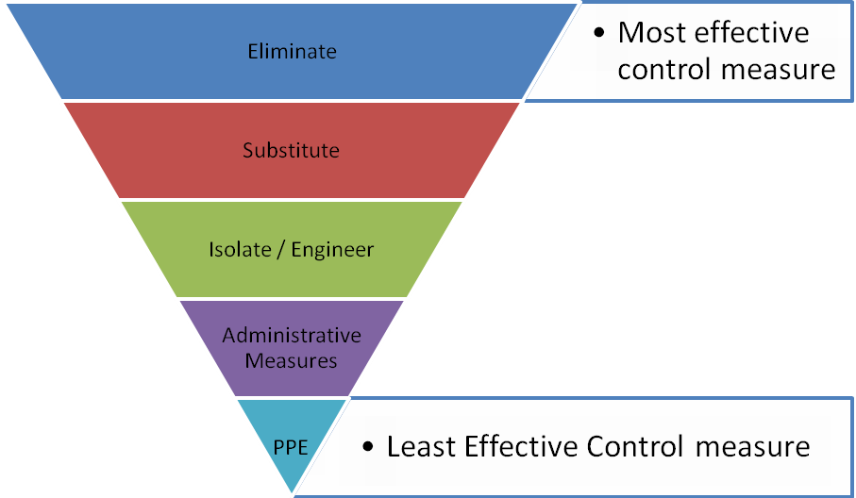
 |  |  | 1 |  | 2 | 3 | 4 | 5
 |  |  | Insignificant |  | Minor | Moderate | Major | Catastrophic
A. | Almost certain |  | M 52 |  | H 64 | E 76 | E 88 | E 100
B. | Likely |  | M 44 |  | H 56 | H 68 | E 80 | E 92
C. | Possible |  | L 36 |  | M 48 | H 60 | E 72 | E 84
D. | Unlikely |  | L 28 |  | L 40 | M 52 | H 64 | E 76
E. | Rare |  | L 20 |  | L 32 | M 44 | H 56 | H 68
SCORE INDICATOR
SCORE |  | LEVEL OF DANGER |  | REQUIRED ACTION
72 – 100 |  | EXTREME |  | NO WORK SHOULD COMMENCE AT THIS LEVEL!  This is an unacceptable level of risk. A review of controls must be performed to reduce risk as low as reasonably practicable. If risk cannot be further reduced, a Permit System must be applied. The permit must be available at all times work is being performed, signed by both the workers, a senior management representative and the Client (if applicable) to ensure that the risk is reduced as far as practicable.
56 – 68 |  | HIGH |  | WORK CAN COMMENCE AT THIS LEVEL IF THE CONTROL MEASURES ARE APPROVED BY THE PROJECT MANAGER OR DELEGATE  The Project Manager or delegate will review existing controls to ensure that the risk is reduced to as low as is reasonably practicable.
44 – 52 |  | MODERATE |  | WORK CAN COMMENCE WITH CONTROL MEASURES IN PLACE.  Management must monitor and review the controls to ensure controls are adequately used, do not present further hazards / risks and aim to reduce the risk further if practicable.
20 - 40 |  | LOW |  | REVIEW IF CHANGES OCCUR.  Record and review if any equipment, people, materials, work processes, or procedures change.

- MONITORING AND REVIEW OF CONTROL MEASURES
Pre-Start | Pre-start meetings are held to review control measures and ensure workers are aware of controls.
Ongoing Monitoring | Site Supervisor will continually monitor works against the controls stated in this safe work method statement. The Health and Safety Checklist is used to document formal inspections of the works and work area.
Annual | This safe work method statement is reviewed annually or as required.
NON-CONFORMANCE | Should any aspect of this SWMS not be complied with, work affected by the non-compliance must cease. The Site Supervisor will either enforce the controls as stated by the SWMS or, where appropriate, review the SWMS in consultation with workers and update with more suitable controls provided the revised controls still ensure that the hazards / risks are controlled as far as reasonably practicable.

- SWMS CONSULTATION AND SIGN-OFF RECORD
I confirm, by signing below, that I have read and understand the requirements of this SWMS, that I agree that the SWMS is acceptable for the proposed work, and I agree to abide by the requirements. If the work conditions change, or additional hazards are identified, these changes shall be discussed, the SWMS modified and signed again.
ISSUE | NAME (Please Print) | SIGNATURE | ISSUE | NAME (Please Print) | SIGNATURE
A
A
A
A
A
A
A
A
A
A
A
A
A
A
A

