SWMS 104 – WORK AT HEIGHTS: USING LADDERS
NOTE: This industry standard SWMS template has been made accessible by Breffni Ceilings & Partitions Pty Ltd, to be used as a guide only. The sub-contractor/user is entirely responsible for its contents at the point of submission. Therefore, please ensure that every section is reviewed and personalised in full.

- PROJECT DETAILS
Project Name: |  | Project Address:
Client / Principal Contractor:
Description of Work (Scope):
High Risk Construction Work:
Date Work is to Commence: |  | Approx. Duration of Work:
Person Responsible for Monitoring Activity: |  | Name:
Date Created: |  | Issue: | A

- CONSULTATION
THIS SWMS HAS BEEN DEVELOPED IN CONSULTATION WITH THE FOLLOWING WORKERS: |  |  |  | SWMS PROVIDED TO CLIENT / PRINCIPAL CONTRACTOR
Issue: | Name: | Position: | Date: | Issue: | Name: | Position: | Date:
A |  |  |  | A

- APPROVAL
 | APPROVED BY | REVIEWED PRIOR TO WORK COMMENCING  (Principal Contractor Representative) | REVIEWED ON SITE PRIOR TO COMMENCING WORK  (Site Supervisor)
NAME
SIGNATURE
DATE

- PERSONAL PROTECTIVE EQUIPMENT
Uniform | Footwear | High Vis’ | Safety Helmet | Protective Eyewear | Face Shield | Fall Arrest | Gloves | Hearing | Dust Mask | Respirator | Other | PPE. Notes (e.g. P2 Dust Mask, etc.)
 |  |  |  |  |  | 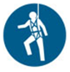 |  |  |  |  |  | Other mandatory site PPE as advised by Client or PC.

- PERMITS, TICKETS OR LICENCES REQUIRED TO PERFORM WORK
Role / Task | Training, Permit, Ticket or Licence
Workers | Company Induction, General Construction Induction
Working from over 2 m | General Work from Heights training

- PLANT AND EQUIPMENT
Plant and Equipment Description | Maintenance / Checks / Tests | Plant and Equipment Description | Maintenance / Checks / Tests
Ladders | Visual Inspection prior to use by worker.
Nonslip shoes | Visual Inspection prior to use by worker.

- CHEMICALS
Chemical Name | Hazardous? | SDS Attached | Controls
 | Yes No | Yes No | As per Safety Data Sheet
 | Yes No | Yes No

- LEGISLATION AUSTRALIAN STANDARDS AND CODES OF PRACTICE TO BE COMPLIED WITH
QUEENSLAND |  |  |  |  | NATIONAL
Work Health and Safety Act 2011 |  |  |  |  | AS/NZS 1891.1:2007/Amdt 2:2008 Industrial Fall-Arrest Systems and Devices - Harnesses and ancillary equipment
Work Health and Safety Regulation 2011 |  |  |  |  | AS/NZS 1891.4:2009 Industrial Fall-Arrest Systems and Devices - Selection, Use and Maintenance
How to Manage Work Health and Safety Risks Code of Practice 2011 |  |  |  |  | AS/NZS 1892.5:2000 Portable ladders - Selection, safe use and care
Managing the Risk of Falls at Workplaces Code of Practice 2011
Managing Risks of Plant in the Workplace Code of Practice 2013
Hazardous Manual Tasks Code of Practice 2011
WHS Consultation, Co-operation and Co-ordination Code of Practice 2011
- WORK RISKS AND CONTROLS
Item No. | Job Procedure in Steps | Possible Health, Safety and Environmental Hazards/ Risks | Risk Score Before | Health, Safety and Environmental Controls |  | Risk Score After | Person(s) Responsible
 | Pre-start | Workers not understanding risk controls | E 80 | Pre-start meeting with workers to discuss requirements of this SWMS.  Feedback will be requested from workers.  All workers to sign off accordingly. |  | M 52 | Site Supervisor
 | Ladder selection | Electric shock  Fall from heights  Musculoskeletal injury | E 88 | Inspect ladder for defects, do not use damaged equipment.  Only use ladders that are owned by Breffni Ceilings & Partitions Pty ltd. Do not loan equipment to others.  Make sure that ladders are:  - In good condition;  - An appropriate height to comfortably perform the work required;  - Have a rated capacity of at least 120kg;  - Identified by the manufacturer as “for industrial use”;  - Used only for the purpose for which it was designed;  - Non-conductive (i.e. fibreglass) if there is a risk of electrocution; and  - No longer than 6.1 metres for single ladders and 7.5 metres for extension ladders (9.2 m for an extension ladder used to do electrical work). |  | M 52 | Worker  Site Supervisor
 | Preparing work area | Slips, trips and falls | H 60 | Make sure area is clear of obstacles. |  | L 40 | Worker
 | Ensure ladder is erected and secured as indicated in Project Risk Assessment | Injuries from falling objects | H 60 | Erect appropriate barricading and signage to exclude others from entering the area below elevated work.  Tethers must be used to tie-off tools, equipment and materials. |  | L 40 | Worker
 |  | Manual Handling | E 80 | Seek assistance with any manual handling task that you feel you cannot do safely. Follow safe manual handling guidelines.  Check the distance to be travelled. Ensure the path you will use is clear of obstructions.  If you are not fully fit for work, due to any form of injury, report this to your Manager. |  | M 52 | Worker
 | Using a step ladder | Ladder sliding out  Ladder tilting  User slipping  User loss of balance | H 60 | Step ladder is only to be used when access is not possible from a platform ladder.  If no platform ladder is available, ensure step ladder is:  - Locked into the open position by fully depressing the support struts;  - Set up in an area free from obstacles; and  - NOT used to support a work platform.  Do not leave tools or materials on top of a stepladder while unattended.  Site Supervisor is to monitor the controls. |  | L 40 | Worker
 | Using a single or extension ladder. | Ladder sliding out  Ladder tilting  User loss of balance | E 80 | Make sure only one person is on the ladder at one time.  Make sure 3 limbs are holding, wrapped around or standing on the ladder at all times, unless otherwise secured by a means of fall protection.  Do not stand higher than the third rung from the top of the ladder.  Make sure that your body remains within the stiles of the ladder.  Avoid stretching and extending.  Face the ladder when climbing up or down. |  | M 52 | Worker
 |  | Ladder sliding out  Ladder tilting | E 80 | Position ladders:  - On a stable and level surface free from obstacles;  - So that the rungs are approximately level;  - So that the angle between the ladder and the horizontal is at least 70º but not more than 80º when in use;  - So that the end extends 1 metre above a surface if it is being used as a means of temporary access.  Secure the ladder by tying off to a firm upright surface or secured by the use of bracing.  Where a tie off point is not available, use a second person to support the ladder whilst in use. |  | M 52 | Worker
 |  | User slipping | E 72 | Make sure that the ladder rungs and safety boots are not slippery. |  | L 40 | Worker
 |  | Ladder falling  User loss of balance | E 80 | Make sure only one person is on the ladder at one time.  Make sure 3 limbs are holding, wrapped around or standing on the ladder at all times.  Make sure that your body remains within the work platform of the ladder.  Avoid stretching and extending.  Face the ladder when climbing up or down. |  | M 52 | Worker
 | Using a platform ladder | Fall from heights | E 80 | Ensure platform ladders are:  - Locked into the open position by fully depressing the support struts; and  - Set up in an area free from obstacles.  Make sure 3 limbs are holding, wrapped around or standing on the ladder at all times, unless otherwise secured by a means of fall protection.  Where, due to the nature of the task, 3 points of contact (limbs) cannot be maintained, the third point of contact will be achieved by leaning against the front bar of the platform ladder thereby ensuring the position on the platform is maintained away from the rear edge.  Do not leave tools or materials on top of a platform while unattended. |  | M 52 | Worker
 |  | User slipping | H 60 | Make sure that the ladder rungs and safety boots are not slippery. |  | L 40 | Worker
 | Using materials and tools on a ladder | Manual handling  User loss of balance | H 68 | Do not carry tools or materials by hand up a ladder.  Use approved shoulder bags or tool belts for the carrying of small tools and materials, leaving both hands free to grasp the ladder stiles.  Haul larger tools or materials up to the work area by the use of a rope or other lifting apparatus. |  | L 40 | Worker
 | Site Emergency | Poor or delayed response in the case of emergency | E 80 | Site specific emergency procedures will be followed at all times. |  | L 40 | Worker  Site Supervisor

- RISK ASSESSMENT TOOL
RISK MATRIX |  |  |  |  |  |  |  |  | HIERARCHY OF CONTROLS
LIKELIHOOD |  |  | CONSEQUENCE |  |  |  |  |  | 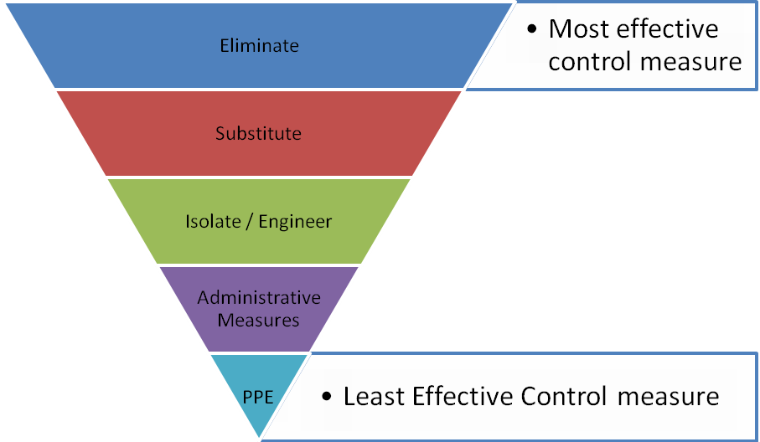
 |  |  | 1 |  | 2 | 3 | 4 | 5
 |  |  | Insignificant |  | Minor | Moderate | Major | Catastrophic
A. | Almost certain |  | M 52 |  | H 64 | E 76 | E 88 | E 100
B. | Likely |  | M 44 |  | H 56 | H 68 | E 80 | E 92
C. | Possible |  | L 36 |  | M 48 | H 60 | E 72 | E 84
D. | Unlikely |  | L 28 |  | L 40 | M 52 | H 64 | E 76
E. | Rare |  | L 20 |  | L 32 | M 44 | H 56 | H 68
SCORE INDICATOR
SCORE |  | LEVEL OF DANGER |  | REQUIRED ACTION
72 – 100 |  | EXTREME |  | NO WORK SHOULD COMMENCE AT THIS LEVEL!  This is an unacceptable level of risk. A review of controls must be performed to reduce risk as low as reasonably practicable. If risk cannot be further reduced, a Permit System must be applied. The permit must be available at all times work is being performed, signed by both the workers, a senior management representative and the Client (if applicable) to ensure that the risk is reduced as far as practicable.
56 – 68 |  | HIGH |  | WORK CAN COMMENCE AT THIS LEVEL IF THE CONTROL MEASURES ARE APPROVED BY THE PROJECT MANAGER OR DELEGATE  The Project Manager or delegate will review existing controls to ensure that the risk is reduced to as low as is reasonably practicable.
44 – 52 |  | MODERATE |  | WORK CAN COMMENCE WITH CONTROL MEASURES IN PLACE.  Management must monitor and review the controls to ensure controls are adequately used, do not present further hazards / risks and aim to reduce the risk further if practicable.
20 - 40 |  | LOW |  | REVIEW IF CHANGES OCCUR.  Record and review if any equipment, people, materials, work processes, or procedures change.

- MONITORING AND REVIEW OF CONTROL MEASURES
Pre-Start | Pre-start meetings are held to review control measures and ensure workers are aware of controls.
Ongoing Monitoring | Site Supervisor will continually monitor works against the controls stated in this safe work method statement. The Health and Safety Checklist is used to document formal inspections of the works and work area.
Annual | This safe work method statement is reviewed annually or as required.
NON-CONFORMANCE | Should any aspect of this SWMS not be complied with, work affected by the non-compliance must cease. The Site Supervisor will either enforce the controls as stated by the SWMS or, where appropriate, review the SWMS in consultation with workers and update with more suitable controls provided the revised controls still ensure that the hazards / risks are controlled as far as reasonably practicable.

- SWMS CONSULTATION AND SIGN-OFF RECORD
I confirm, by signing below, that I have read and understand the requirements of this SWMS, that I agree that the SWMS is acceptable for the proposed work, and I agree to abide by the requirements. If the work conditions change, or additional hazards are identified, these changes shall be discussed, the SWMS modified and signed again.
ISSUE | NAME (Please Print) | SIGNATURE | ISSUE | NAME (Please Print) | SIGNATURE
A
A
A
A
A
A
A
A
A
A
A
A
A
A
A

