SWMS 105 – WORK AT HEIGHTS: USING FALL ARREST SYSTEMS
NOTE: This industry standard SWMS template has been made accessible by Breffni Ceilings & Partitions Pty Ltd, to be used as a guide only. The sub-contractor/user is entirely responsible for its contents at the point of submission. Therefore, please ensure that every section is reviewed and personalised in full.

- PROJECT DETAILS
Project Name: |  | Project Address:
Client / Principal Contractor:
Description of Work (Scope):
High Risk Construction Work:
Date Work is to Commence: |  | Approx. Duration of Work:
Person Responsible for Monitoring Activity: |  | Name:
Date Created: |  | Issue: | A

- CONSULTATION
THIS SWMS HAS BEEN DEVELOPED IN CONSULTATION WITH THE FOLLOWING WORKERS: |  |  |  | SWMS PROVIDED TO CLIENT / PRINCIPAL CONTRACTOR
Issue: | Name: | Position: | Date: | Issue: | Name: | Position: | Date:
A |  |  |  | A

- APPROVAL
 | APPROVED BY | REVIEWED PRIOR TO WORK COMMENCING  (Principal Contractor Representative) | REVIEWED ON SITE PRIOR TO COMMENCING WORK  (Site Supervisor)
NAME
SIGNATURE
DATE

- PERSONAL PROTECTIVE EQUIPMENT
Uniform | Footwear | High Vis’ | Safety Helmet | Protective Eyewear | Face Shield | Fall Arrest | Gloves | Hearing | Dust Mask | Respirator | Other | PPE. Notes (e.g. P2 Dust Mask, etc.)
 |  |  |  |  |  | 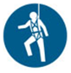 |  |  |  |  |  | Other mandatory site PPE as advised by Client or PC.

- PERMITS, TICKETS OR LICENCES REQUIRED TO PERFORM WORK
Role / Task | Training, Permit, Ticket or Licence
Workers | Company Induction, General Construction Induction
Working from over 2 m | General Work from Heights training
Use of Fall Arrest Equipment | Use and safety measures for equipment
6 and 12 monthly Inspection of Travel restraint systems | Height Safety Equipment Inspector

- PLANT AND EQUIPMENT
Plant and Equipment Description | Maintenance / Checks / Tests | Plant and Equipment Description | Maintenance / Checks / Tests
Fall arrest equipment | Visually inspected before use.  Tested as per manufacturer’s instructions.

- CHEMICALS
Chemical Name | Hazardous? | SDS Attached | Controls
 | Yes No | Yes No | As per Safety Data Sheet
 | Yes No | Yes No

- LEGISLATION AUSTRALIAN STANDARDS AND CODES OF PRACTICE TO BE COMPLIED WITH
QUEENSLAND | NATIONAL
Work Health and Safety Act 2011 | AS/NZS 1891.1:2007/Amdt 2:2008 Industrial Fall-Arrest Systems and Devices - Harnesses and ancillary equipment
Work Health and Safety Regulation 2011 | AS/NZS 1891.3:1997 Industrial Fall-Arrest Systems and Devices - Fall Arrest Devices
How to Manage Work Health and Safety Risks Code of Practice 2011 | AS/NZS 1891.4:2009 Industrial Fall-Arrest Systems and Devices - Selection, Use and Maintenance
WHS Consultation, Co-operation and Co-ordination Code of Practice 2011
Managing the Risk of Falls at Workplaces Code of Practice 2011

- WORK RISKS AND CONTROLS
Item No. | Job Procedure in Steps | Possible Health, Safety and Environmental Hazards/ Risks | Risk Score Before | Health, Safety and Environmental Controls | Risk Score After | Person(s) Responsible
 | Pre-start | Workers not understanding risk controls | E 80 | Pre-start meeting with workers to discuss requirements of this SWMS.  Feedback will be requested from workers.  All workers to sign off accordingly. | M 52 | Site Supervisor
 | Assess the area | Site specific hazards | E 72 | Identify any hazards within the immediate work environment that may create a risk for the people doing the job. | M 52 | Worker  Site Supervisor
 | Training of workers | Workers unable to use systems correctly | E 88 | All workers will be trained in the use of fall-arrest systems and adequate supervision will be provided. | M 52 | Site Supervisor
**INDICATE WHICH FALL PROTECTION MEASURE/S WILL BE UTILISED**
 | Utilising a fall arresting platform  Yes  No | Not provide adequate fall protection | E 88 | Fall arresting platforms will be:  - Able to withstand the impact of a fall;  - Provide an unobstructed landing area; and  - Placed as close as possible to the underside of the work area to minimise the distance a person can fall from the work platform. | M 52 | Site Supervisor
 | Utilising an industrial safety net  Yes  No | Not provide adequate fall protection | E 88 | Ensure net is placed so that there is no risk of falling persons hitting objects below the net.  Ensure the net is as close as possible to the work area.  Ensure the net is installed, used, inspected, and maintained as per manufacturer’s or supplier’s instructions. | M 52 | Site Supervisor
 | Utilising a fall arrest harness system  Yes  No | Not provide adequate fall protection | E 88 | Workers will not work in isolation.  The lanyard will be as short as possible with a working slack length of not more than 2 metres, to minimise the pendulum effect.  Personnel must be attached to appropriately placed anchorage points, via lanyard, before they are at risk of falling.  Components of fall–arrest system are to be compatible.  The fall-arrest harness system must be fitted so that there is enough distance available for a person using the system to fall but prevent the person hitting an object, the ground or another surface (other than a vertical surface).  Enough distance is established by considering:  - The user’s height;  - The height and position of the anchorage point;  - The length of the lanyard, any slack in the static line;  - Any stretching of the lanyard or static line when extended by a fall;  - The length of the energy absorber when extended by a fall;  - Any other relevant factor.  Fall-arrest harness will be correctly fitted, loose harnesses are a significant risk, therefore harness systems must be installed and maintained in accordance with manufacturer’s instructions. | M 52 | Worker  Site Supervisor
 | Fitting harness | Death or injury resulting from harness failure | E 88 | Inspect the harness for damage- Do not use faulty equipment.  Holding both shoulder straps, don the harness like a jacket.  Pass the leg straps from the rear between the legs. Left strap to the left buckle, right strap to the right buckle.  Do not cross the leg straps.  Fasten the buckle by passing one plate through the other. Ensure the plates fit flat against each other.  Fasten the chest or waist strap.  Check that straps are not twisted.  Adjust the leg straps and shoulder straps to a comfortable tightness, without undue pressure on the shoulders or pelvic area.  Ensure the strap is not twisted, buckled or deformed at the buckle. | M 52 | Worker
 | Attaching to anchorage | Inadequate anchorage | E 88 | Select a rigid anchorage point in the vertical axis of the working zone. Never use an anchorage point that could damage the lanyard or attachment devices. Ensure the lanyard is not obstructed, becoming tangled or abraded. | M 52 | Worker  Site Supervisor
 |  | Inadequate lanyard | E 88 | Connect the personal energy absorber end of the lanyard assembly to the harness at the marked “D” placed high on the harness between the shoulder blades.  Connect the long strap end or strap reel on retractable lanyards to the anchorage using a Karabiner and webbing sling if required. | M 52 | Worker
 |  | Lack of free fall clearance | E 88 | Ensure that you consider what you will hit if you free-fall. The anchorage point will be of sufficient height above the ground or structure to allow for the maximum lanyard length. | M 52 | Worker  Site Supervisor
 |  | Equipment damage | E 72 | If any part of the equipment has been previously involved in a fall, exposed to chemicals, or in other ways damaged, it will be placed OUT OF SERVICE.  Check for distortion of the snap hooks, latches, karabiners, D Rings, weak latch springs, worn pivot pins and obstructed movement, exposed shock absorbing material, stretching, cuts, abrasion or fraying of rope or webbing, loose or missing stitching, correct operation of reel and lock on retractable lanyards, heat, corrosive or mechanical damage. | M 52 | Worker
 | Rescue of fallen worker | Death or injury | E 80 | A worker suspended from a fall arrest system is classified as an emergency. Rescue must be undertaken within 3-5 minutes to ensure that physical side effects of being suspended do not develop.  When using a fall arrest system, a Rescue Plan must be in place. This plan will be identified before the person works at height and will involve the use of available resources to reach a fallen worker, and the co-worker who is acting as the Safety Observer. | M 52 | Worker  Site Supervisor
 | Falling equipment hitting passers-by | Equipment falling whilst being used above ground level | E 72 | An overhead or catch platform will be in place if a risk assessment finds a high risk from falling objects.  Tethers must be used to tie-off tools, equipment and materials.  Equipment used at height i.e. above ground level is to have a lanyard fitted which is to be attached to the person using the item. When not in use, the lanyard is to be fixed to an anchor point.  Anchor point and lanyard must not exceed length where equipment may impact people or plant if it is dropped or falls.  Where possible, pedestrian access is to be restricted. | L 40 | Worker  Site Supervisor
 | Site Emergency | Poor or delayed response in the case of emergency | E 80 | Site specific emergency procedures will be followed at all times. | L 40 | Worker  Site Supervisor

- RISK ASSESSMENT TOOL
RISK MATRIX |  |  |  |  |  |  |  |  | HIERARCHY OF CONTROLS
LIKELIHOOD |  |  | CONSEQUENCE |  |  |  |  |  | 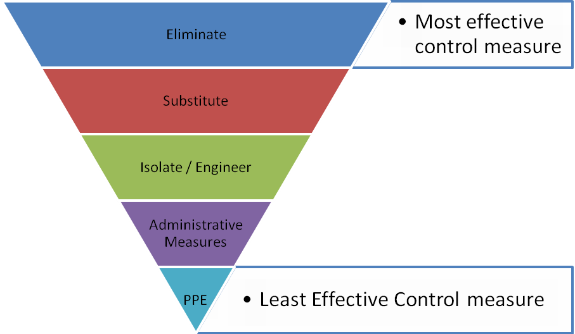
 |  |  | 1 |  | 2 | 3 | 4 | 5
 |  |  | Insignificant |  | Minor | Moderate | Major | Catastrophic
A. | Almost certain |  | M 52 |  | H 64 | E 76 | E 88 | E 100
B. | Likely |  | M 44 |  | H 56 | H 68 | E 80 | E 92
C. | Possible |  | L 36 |  | M 48 | H 60 | E 72 | E 84
D. | Unlikely |  | L 28 |  | L 40 | M 52 | H 64 | E 76
E. | Rare |  | L 20 |  | L 32 | M 44 | H 56 | H 68
SCORE INDICATOR
SCORE |  | LEVEL OF DANGER |  | REQUIRED ACTION
72 – 100 |  | EXTREME |  | NO WORK SHOULD COMMENCE AT THIS LEVEL!  This is an unacceptable level of risk. A review of controls must be performed to reduce risk as low as reasonably practicable. If risk cannot be further reduced, a Permit System must be applied. The permit must be available at all times work is being performed, signed by both the workers, a senior management representative and the Client (if applicable) to ensure that the risk is reduced as far as practicable.
56 – 68 |  | HIGH |  | WORK CAN COMMENCE AT THIS LEVEL IF THE CONTROL MEASURES ARE APPROVED BY THE PROJECT MANAGER OR DELEGATE  The Project Manager or delegate will review existing controls to ensure that the risk is reduced to as low as is reasonably practicable.
44 – 52 |  | MODERATE |  | WORK CAN COMMENCE WITH CONTROL MEASURES IN PLACE.  Management must monitor and review the controls to ensure controls are adequately used, do not present further hazards / risks and aim to reduce the risk further if practicable.
20 - 40 |  | LOW |  | REVIEW IF CHANGES OCCUR.  Record and review if any equipment, people, materials, work processes, or procedures change.

- MONITORING AND REVIEW OF CONTROL MEASURES
Pre-Start | Pre-start meetings are held to review control measures and ensure workers are aware of controls.
Ongoing Monitoring | Site Supervisor will continually monitor works against the controls stated in this safe work method statement. The Health and Safety Checklist is used to document formal inspections of the works and work area.
Annual | This safe work method statement is reviewed annually or as required.
NON-CONFORMANCE | Should any aspect of this SWMS not be complied with, work affected by the non-compliance must cease. The Site Supervisor will either enforce the controls as stated by the SWMS or, where appropriate, review the SWMS in consultation with workers and update with more suitable controls provided the revised controls still ensure that the hazards / risks are controlled as far as reasonably practicable.

- SWMS CONSULTATION AND SIGN-OFF RECORD
I confirm, by signing below, that I have read and understand the requirements of this SWMS, that I agree that the SWMS is acceptable for the proposed work, and I agree to abide by the requirements. If the work conditions change, or additional hazards are identified, these changes shall be discussed, the SWMS modified and signed again.
ISSUE | NAME (Please Print) | SIGNATURE | ISSUE | NAME (Please Print) | SIGNATURE
A
A
A
A
A
A
A
A
A
A
A
A
A
A

