SWMS 106 – WORK AT HEIGHTS: ROOF WORK
NOTE: This industry standard SWMS template has been made accessible by Breffni Ceilings & Partitions Pty Ltd, to be used as a guide only. The sub-contractor/user is entirely responsible for its contents at the point of submission. Therefore, please ensure that every section is reviewed and personalised in full.

- PROJECT DETAILS
Project Name: |  | Project Address:
Client / Principal Contractor:
Description of Work (Scope):
High Risk Construction Work: | Working on a roof with a pitch that is greater than 26 degrees, Work which involves the risk of falling from more than 2 metres.
Date Work is to Commence: |  | Approx. Duration of Work:
Person Responsible for Monitoring Activity: |  | Name:
Date Created: |  | Issue: | A

- CONSULTATION
THIS SWMS HAS BEEN DEVELOPED IN CONSULTATION WITH THE FOLLOWING WORKERS: |  |  |  | SWMS PROVIDED TO CLIENT / PRINCIPAL CONTRACTOR
Issue: | Name: | Position: | Date: | Issue: | Name: | Position: | Date:
A |  |  |  | A

- APPROVAL
 | APPROVED BY | REVIEWED PRIOR TO WORK COMMENCING  (Principal Contractor Representative) | REVIEWED ON SITE PRIOR TO COMMENCING WORK  (Site Supervisor)
NAME
SIGNATURE
DATE

- PERSONAL PROTECTIVE EQUIPMENT
Uniform | Footwear | High Vis’ | Safety Helmet | Protective Eyewear | Face Shield | Fall Arrest | Gloves | Hearing | Dust Mask | Respirator | Other | PPE. Notes (e.g. P2 Dust Mask, etc.)
 |  |  |  |  |  | 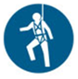 |  |  |  |  |  | Other mandatory site PPE as advised by Client or PC.

- PERMITS, TICKETS OR LICENCES REQUIRED TO PERFORM WORK
Role / Task | Training, Permit, Ticket or Licence
Workers | Company Induction, General Construction Induction
Working from over 2 m | General Work from Heights training
Use of Fall Arrest Equipment | Use and safety measures for equipment
6 and 12 monthly Inspection of Travel restraint systems | Height Safety Equipment Inspector

- PLANT AND EQUIPMENT
Plant and Equipment Description | Maintenance / Checks / Tests | Plant and Equipment Description | Maintenance / Checks / Tests
Fall arrest equipment | Visually inspected before use.  Tested as per manufacturer’s instructions.
Guardrails | Visually inspected before use.

- CHEMICALS
Chemical Name | Hazardous? | SDS Attached | Controls
 | Yes No | Yes No | As per Safety Data Sheet
 | Yes No | Yes No
 | Yes No | Yes No
 | Yes No | Yes No

- LEGISLATION AUSTRALIAN STANDARDS AND CODES OF PRACTICE TO BE COMPLIED WITH
QUEENSLAND | NATIONAL
Work Health and Safety Act 2011 | AS/NZS 1891.1:2007/Amdt 2:2008 Industrial Fall-Arrest Systems and Devices - Harnesses and ancillary equipment
Work Health and Safety Regulation 2011 | AS/NZS 1891.3:1997 Industrial Fall-Arrest Systems and Devices - Fall Arrest Devices
Scaffolding Code of Practice 2009 | AS/NZS 1891.4:2009 Industrial Fall-Arrest Systems and Devices - Selection, Use and Maintenance
How to Manage Work Health and Safety Risks Code of Practice 2011 | AS/NZS 4389:2015 Roof Safety Mesh
Managing Risks of Plant in the Workplace Code of Practice 2013 | AS/NZS 1577:2013 Scaffold Decking Components
Hazardous Manual Task Code of Practice 2011 | AS/NZS 1576.1:2010 Scaffolding – General Requirements
WHS Consultation, Co-operation and Co-ordination Code of Practice 2011 | AS/NZS 3760 :2010 In-Service Safety Inspection and Testing of Electrical Equipment
Managing the Risk of Falls at Workplaces Code of Practice 2011 | AS 2550.10:2006 Cranes, Hoists and Winches – Safe use – Mobile elevating Work Platforms
 | AS/NZS 4576:1995 Guidelines for Scaffolding

- WORK RISKS AND CONTROLS
Item No. | Job Procedure in Steps | Possible Health, Safety and Environmental Hazards/ Risks | Risk Score Before | Health, Safety and Environmental Controls | Risk Score After | Person(s) Responsible
 | Pre-start | Workers not understanding risk controls | E 80 | Pre-start meeting with workers to discuss requirements of this SWMS.  Feedback will be requested from workers.  All workers to sign off accordingly. | M 52 | Site Supervisor
 | General | Fall from heights | E 88 | Do not work on a roof alone – work in pairs.  Establish a clear zone around the perimeter of the building which must:  - Extend two metres from the edge of the gutter line outwards;  - Be natural soil;  - Barricade to prevent public from entering; and  - Be free from building materials, hard surfaces and obstacles.  A physical fall protection system needs to be established when:  - The pitch of the roof is greater than 26 degrees; or  - Working from heights where you can fall from 2 metres; or  - Clear zone cannot be established; or  - Clear zone is no longer maintained. | M 52 | Worker  Site Supervisor
 | Utilising a physical fall protection system – Guardrails | Fall from heights | E 88 | A physical fall protection system is full perimeter protection by guardrails outside roof line.  The installation includes:  - Toeboards or mesh refill to prevent materials, tools, debris falling from the roof;  - A clear gap between rails not exceeding 450mm;  - No gap between roof edge (including gutters) and a guardrail located outside the roof line exceeding 100mm;  - A clear distance between the roof cladding and the bottom rail of not less than 150mm and not greater than 275mm;  - Effective guardrail height above the roof surface of not less than 900mm or greater than 1100mm;  - Non-structural infill panels were the pitch of the roof exceeds 26 degrees. | M 52 | Site Supervisor
 | Utilising an industrial safety net | Fall from heights | E 88 | Ensure safety net is:  - Designed by an engineer or competent person to minimise injury to a person falling into the net;  - Placed so that there is no risk of falling persons hitting objects below the net;  - As close as possible to the work area;  - Installed, used, inspected and maintained as per manufacturers or supplier’s instructions. | M 52 | Site Supervisor
 | Utilising a fall arrest system | Fall from heights | E 88 | Follow SWMS Work at Heights: Using Fall Arrest Systems | M 52 | Worker  Site Supervisor
 | Utilising a warning line and safety monitoring system | Fall from heights | E 88 | The warning line is installed 2 metres from the edge at a height of 1 metre with flags approximately every 1.7 metres. This barrier creates a safe working area in which workers can work without the risk of falling off the edge of the roof.  Any work conducted outside of this area requires the supervision of a safety monitor. A fall protection harness must be worn at all times when working outside of the safe working area.  It is the role of the safety monitor to watch and warn roof workers of the edge, at all times they must have a clear view of all workers. Safety monitors must not have any other duties. | M 52 | Worker  Site Supervisor
 | Utilising safety mesh | Fall through | E 88 | Safety mesh used will comply with AS/NZS 4389:2015 – Roof Safety Mesh. Safety mesh chosen will be strong enough to support a person who may fall onto it.  No work will commence until the safety mesh is installed.  Risk assessments will assess that the mesh has been installed correctly and there are secure connections to the building and appropriate overlap between adjacent sections of mesh.  If purlin spacing is 1200 or greater the mesh is to be fastened on the side laps. If purlin spacing is 2200 or greater mesh is to be double lapped and fastened on both sides of the laps. Mesh is to be pulled taut to ensure a natural sag between each purlin. This natural sag shall not be modified to create artificial sag. | M 52 | Worker  Site Supervisor
 | Travel restraint system | Fall from heights | E 80 | Follow SWMS Work at Heights: Using Fall Prevention | M 52 | Worker  Supervisor
 | Housekeeping | Trips and falls – rolling off roof | E 80 | Good housekeeping will be observed to ensure that trip hazards are not present. | M 44 | Worker  Site Supervisor
 | Site Emergency | Poor or delayed response in the case of emergency | E 80 | Site specific emergency procedures will be followed at all times. | L 40 | Worker  Site Supervisor

- RISK ASSESSMENT TOOL
RISK MATRIX |  |  |  |  |  |  |  |  | HIERARCHY OF CONTROLS
LIKELIHOOD |  |  | CONSEQUENCE |  |  |  |  |  | 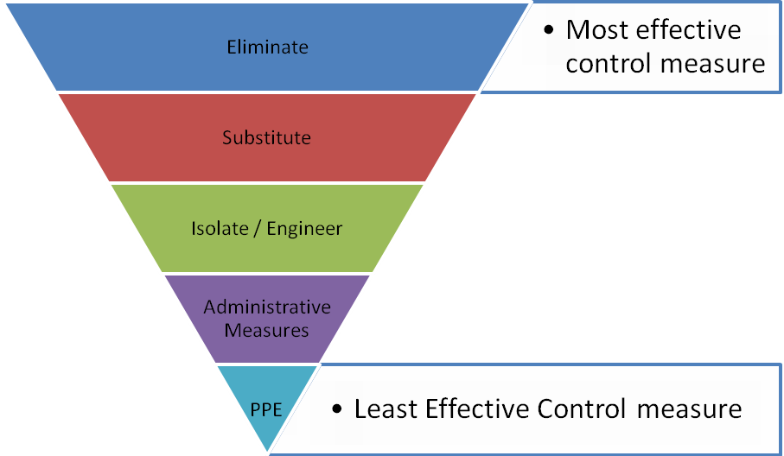
 |  |  | 1 |  | 2 | 3 | 4 | 5
 |  |  | Insignificant |  | Minor | Moderate | Major | Catastrophic
A. | Almost certain |  | M 52 |  | H 64 | E 76 | E 88 | E 100
B. | Likely |  | M 44 |  | H 56 | H 68 | E 80 | E 92
C. | Possible |  | L 36 |  | M 48 | H 60 | E 72 | E 84
D. | Unlikely |  | L 28 |  | L 40 | M 52 | H 64 | E 76
E. | Rare |  | L 20 |  | L 32 | M 44 | H 56 | H 68
SCORE INDICATOR
SCORE |  | LEVEL OF DANGER |  | REQUIRED ACTION
72 – 100 |  | EXTREME |  | NO WORK SHOULD COMMENCE AT THIS LEVEL!  This is an unacceptable level of risk. A review of controls must be performed to reduce risk as low as reasonably practicable. If risk cannot be further reduced, a Permit System must be applied. The permit must be available at all times work is being performed, signed by both the workers, a senior management representative and the Client (if applicable) to ensure that the risk is reduced as far as practicable.
56 – 68 |  | HIGH |  | WORK CAN COMMENCE AT THIS LEVEL IF THE CONTROL MEASURES ARE APPROVED BY THE PROJECT MANAGER OR DELEGATE  The Project Manager or delegate will review existing controls to ensure that the risk is reduced to as low as is reasonably practicable.
44 – 52 |  | MODERATE |  | WORK CAN COMMENCE WITH CONTROL MEASURES IN PLACE.  Management must monitor and review the controls to ensure controls are adequately used, do not present further hazards / risks and aim to reduce the risk further if practicable.
20 - 40 |  | LOW |  | REVIEW IF CHANGES OCCUR.  Record and review if any equipment, people, materials, work processes, or procedures change.

- MONITORING AND REVIEW OF CONTROL MEASURES
Pre-Start | Pre-start meetings are held to review control measures and ensure workers are aware of controls.
Ongoing Monitoring | Site Supervisor will continually monitor works against the controls stated in this safe work method statement. The Health and Safety Checklist is used to document formal inspections of the works and work area.
Annual | This safe work method statement is reviewed annually or as required.
NON-CONFORMANCE | Should any aspect of this SWMS not be complied with, work affected by the non-compliance must cease. The Site Supervisor will either enforce the controls as stated by the SWMS or, where appropriate, review the SWMS in consultation with workers and update with more suitable controls provided the revised controls still ensure that the hazards / risks are controlled as far as reasonably practicable.

- SWMS CONSULTATION AND SIGN-OFF RECORD
I confirm, by signing below, that I have read and understand the requirements of this SWMS, that I agree that the SWMS is acceptable for the proposed work, and I agree to abide by the requirements. If the work conditions change, or additional hazards are identified, these changes shall be discussed, the SWMS modified and signed again.
ISSUE | NAME (Please Print) | SIGNATURE | ISSUE | NAME (Please Print) | SIGNATURE
A
A
A
A
A
A
A
A
A
A
A
A
A
A
A
A
A

