SWMS 110 – WORK NEAR ROADS
NOTE: This industry standard SWMS template has been made accessible by Breffni Ceilings & Partitions Pty Ltd, to be used as a guide only. The sub-contractor/user is entirely responsible for its contents at the point of submission. Therefore, please ensure that every section is reviewed and personalised in full.

- PROJECT DETAILS
Project Name: |  | Project Address:
Principal Contractor:
Description of Work (Scope):
High Risk Construction Work: | Work on, or adjacent to, a road
Date Work is to Commence: |  | Approx. Duration of Work:
Person Responsible for Monitoring Activity: |  | Name:
Date Created: |  | Issue: | A

- CONSULTATION
THIS SWMS HAS BEEN DEVELOPED IN CONSULTATION WITH THE FOLLOWING WORKERS: |  |  |  | SWMS PROVIDED TO PRINCIPAL CONTRACTOR
Issue: | Name: | Position: | Date: | Issue: | Name: | Position: | Date:
A |  |  |  | A

- APPROVAL
 | APPROVED BY | REVIEWED PRIOR TO WORK COMMENCING  (Principal Contractor Representative) | REVIEWED ON SITE PRIOR TO COMMENCING WORK  (Site Supervisor)
NAME
SIGNATURE
DATE

- PERSONAL PROTECTIVE EQUIPMENT
Uniform | Footwear | High Vis’ | Safety Helmet | Protective Eyewear | Face Shield | Fall Arrest | Gloves | Hearing | Dust Mask | Respirator | Other | PPE. Notes (e.g. P2 Dust Mask, etc.)
 |  |  |  |  |  | 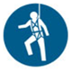 |  |  |  | 

- PERMITS, TICKETS OR LICENCES REQUIRED TO PERFORM WORK
Role / Task | Permit, Ticket or Licence
Workers | Company Induction, General Construction Induction
Controlling Traffic | Traffic Control Permit / Authority, Queensland Traffic Controller Licence

- PLANT AND EQUIPMENT
Plant and Equipment Description | Maintenance / Checks / Tests | Plant and Equipment Description | Maintenance / Checks / Tests
Barricading and signage | Checked daily to ensure that it is in place and effective

- CHEMICALS
Chemical Name | Hazardous? | SDS Attached | Chemical Name | Hazardous? | SDS Attached
 | Yes No | Yes No |  | Yes No | Yes No
 | Yes No | Yes No |  | Yes No | Yes No

- LEGISLATION AUSTRALIAN STANDARDS AND CODES OF PRACTICE TO BE COMPLIED WITH
Queensland | National
Work Health and Safety Act 2011 | AS/NZS 1158.4: 2015 Lighting for Roads and Public Spaces – Lighting of pedestrian crossings
Work Health and Safety Regulation 2011 | AS 1742 Set Manual of uniform control traffic devices set
How to Manage Work Health and Safety Risks Code of Practice 2011 | AS 1743-2001 Road signs - Specifications
 | AS 4191-2015 Portable traffic signal systems
Traffic Management for Construction or Maintenance Work 2008 | AS 4192-2006/Amdt 1-2007 Illuminated flashing arrow signs
Traffic Management for Construction or Maintenance Work 2008 | AS/NZS 1768:2007 Lightning Protection
WHS Consultation, Co-operation and Co-ordination Code of Practice 2011 | AS/NZS 1906.1:2007 Retroreflective materials and devices for road traffic control purposes - Retroreflective sheeting
 | AS/NZS 1906.2:2007 Retroreflective materials and devices for road traffic control purposes - Retroreflective devices (non-pavement application)
 | AS/NZS 1906.1:2007/Amdt 1:2014 Retroreflective materials and devices for road traffic control purposes - Retroreflective sheeting
 | AS/NZS 1906.2:2007 Retroreflective materials and devices for road traffic control purposes - Retroreflective devices (non-pavement application)
 | AS/NZS 1906.4:2010/Amdt 1:2014 Retroreflective materials and devices for road traffic control purposes - High-visibility materials for safety garments
 | AS/NZS 3845.1:2015 Road safety barrier systems and devices - Road safety barrier systems
 | AS/NZS 3845.2:2017 Road safety barrier systems and devices - Road safety devices
 | AS/NZS 4602.1:2011/Amdt 1:2016 High visibility safety garments - Garments for high risk applications

- WORK RISKS AND CONTROLS
Item No. | Job Procedure in Steps | Possible Health, Safety and Environmental Hazards/ Risks | Risk Score Before | Health, Safety and Environmental Controls | Risk Score After | Person(s) Responsible
 | Pre-start | Workers not understanding risk controls | E 80 | Pre-start meeting with workers to discuss requirements of this SWMS.  Feedback will be requested from workers.  All workers to sign off accordingly. | M 52 | Site Supervisor
 | Consultation | Poor awareness of hazards and appropriate control measures | H 68 | Consult with:  - Main Roads, Local Authority or Police Department when working on or near roads where work will disrupt traffic flow or where work becomes dangerous due to the proximity of moving traffic;  - Queensland Rail Department or Corporate Safety Unit on safe work practices near moving or high-volume trains and/or public passing rail areas; and  - Workers about moving equipment on site and traffic procedures | M 52 | Site Supervisor
 | Working near roads | Contact with public traffic | E 80 | Contract a licensed traffic control organisation to implement requirements as prescribed by the MUTCD where:  - Traffic is travelling at more than 60 km/h;  - The work area encroaches nearer than 1.2 metres to the road;  - Work site activities may impede vehicular traffic or pedestrian traffic will be affected; and/or  - Risk to the health and safety of workers and the public is high.  Minimise the number of workers or work area size during times of high traffic movement.  Wear high visibility vests or clothing. | M 52 | Worker  Site Supervisor  Contractor
 | Utilising a Licensed Traffic Control Organisation | Poor control of hazards by subcontracted company | E 80 | Traffic Control Organisation will:  - Create and implement appropriate safe work method statements as required;  - Create and implement a traffic management plan for short term and mobile work, work for simple part road closures and complex traffic arrangements;  - Create and implement a traffic road works signage layout;  - Ensure all traffic controllers are certified by Queensland Transport; and  - Delineate work zones in accordance with the traffic management plan.  Signs will be checked daily and at regular intervals during the day. | M 52 | Site Supervisor  Contractor
 | Set up work area | Contact with public traffic | E 80 | Assess and implement an appropriate signage plan.  Erect barricades to prevent pedestrian access onto the work site and protect workers from traffic.  Signs and barricades will be checked daily and at regular intervals during the day.  Appropriate barricading is mandatory where work may encroach nearer than 1.2 metres to the road.  Place signs and barricades to ensure that:  - Manual of Uniform Traffic Control Devices (MUTCD) requirements are complied with;  - They provide effective and early warning to persons not involved in the task; and  - They allow a sufficient safe working area for those involved in the task. | M 52 | Site Supervisor  Contractor
 | Working near roads where traffic is affected by works | Contact with public while directing traffic | E 80 | Only licensed traffic controllers are permitted to direct traffic. | M 52 | Worker  Site Supervisor  Contractor
 | Access and egress to work area | Trips and falls into the path of traffic | H 60 | Ensure housekeeping is kept at an acceptable level.  Store materials and equipment out of access ways. | L 40 | Worker  Site Supervisor
 | Movement of plant and vehicles on work site | Moving equipment – bodily injury from impact with plant | E 80 | Follow SWMS Work involving Movement of Mobile Plant | M 52 | Worker  Site Supervisor
 | Working around pedestrians | Member of the public tripping or falling on equipments  Impact with site mobile plant | E 80 | Direct pedestrians to a safe route with appropriate barricades, signage or an observer.  Store materials and equipment out of access ways. | L 32 | Worker  Site Supervisor
 | Working at night | Poor visibility – workers or works not being seen | E 80 | Wear high visibility vests or clothing with reflective strips.  Provide adequate artificial lighting. | M 44 | Worker  Site Supervisor
 | Site Emergency | Poor or delayed response in the case of emergency | E 80 | Site specific emergency procedures will be followed at all times. | L 40 | Worker  Site Supervisor

- RISK ASSESSMENT TOOL
RISK MATRIX |  |  |  |  |  |  |  |  | HIERARCHY OF CONTROLS
LIKELIHOOD |  |  | CONSEQUENCE |  |  |  |  |  | 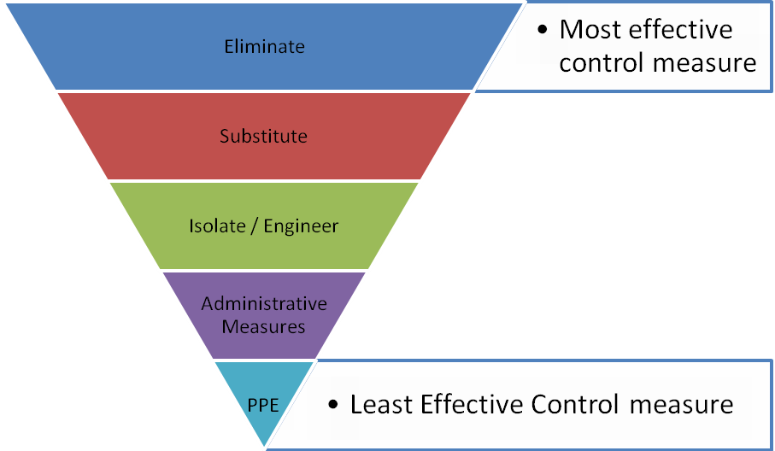
 |  |  | 1 |  | 2 | 3 | 4 | 5
 |  |  | Insignificant |  | Minor | Moderate | Major | Catastrophic
A. | Almost certain |  | M 52 |  | H 64 | E 76 | E 88 | E 100
B. | Likely |  | M 44 |  | H 56 | H 68 | E 80 | E 92
C. | Possible |  | L 36 |  | M 48 | H 60 | E 72 | E 84
D. | Unlikely |  | L 28 |  | L 40 | M 52 | H 64 | E 76
E. | Rare |  | L 20 |  | L 32 | M 44 | H 56 | H 68
SCORE INDICATOR
SCORE |  | LEVEL OF DANGER |  | REQUIRED ACTION
72 – 100 |  | EXTREME |  | NO WORK SHOULD COMMENCE AT THIS LEVEL!  This is an unacceptable level of risk; action must be taken to eliminate or minimise the risk immediately. Report this risk immediately to management.
56 – 68 |  | HIGH |  | WORK CAN COMMENCE AT THIS LEVEL IF THE CONTROL MEASURES ARE APPROVED BY THE PROJECT MANAGER OR DELEGATE  The Project Manager or delegate will review existing controls to ensure that the risk is reduced to as low as is reasonably practicable.
44 – 52 |  | MODERATE |  | WORK CAN COMMENCE WITH CONTROL MEASURES IN PLACE.  Management must monitor and review the controls to ensure controls are adequately used, do not present further hazards / risks and aim to reduce the risk further if practicable.
20 - 40 |  | LOW |  | REVIEW IF CHANGES OCCUR.  Record and review if any equipment, people, materials, work processes, or procedures change.

- MONITORING AND REVIEW OF CONTROL MEASURES
Pre-Start | Pre-start meetings are held to review control measures and ensure workers are aware of controls.
Ongoing Monitoring | Site Supervisor will continually monitor works against the controls stated in this safe work method statement. The Health and Safety Checklist is used to document formal inspections of the works and work area.
Annual | This safe work method statement is reviewed annually or as required.
NON-CONFORMANCE | Should any aspect of this SWMS not be complied with, work affected by the non-compliance must cease. The Site Supervisor will either enforce the controls as stated by the SWMS or, where appropriate, review the SWMS in consultation with workers and update with more suitable controls provided the revised controls still ensure that the hazards / risks are controlled as far as reasonably practicable.

- SWMS CONSULTATION AND SIGN-OFF RECORD
I confirm, by signing below, that I have read and understand the requirements of this SWMS, that I agree that the SWMS is acceptable for the proposed work, and I agree to abide by the requirements. If the work conditions change, or additional hazards are identified, these changes shall be discussed, the SWMS modified and signed again.
ISSUE | NAME (Please Print) | SIGNATURE | ISSUE | NAME (Please Print) | SIGNATURE
A
A
A
A
A
A
A
A
A
A

