SWMS 112 – WORK INVOLVING CRANAGE
NOTE: This industry standard SWMS template has been made accessible by Breffni Ceilings & Partitions Pty Ltd, to be used as a guide only. The sub-contractor/user is entirely responsible for its contents at the point of submission. Therefore, please ensure that every section is reviewed and personalised in full.

- PROJECT DETAILS
Project Name: |  | Project Address:
Client / Principal Contractor:
Description of Work (Scope):
High Risk Construction Work: | Moving powered mobile plant
Date Work is to Commence: |  | Approx. Duration of Work:
Person Responsible for Monitoring Activity: |  | Name:
Date Created: |  | Issue: | A

- CONSULTATION
THIS SWMS HAS BEEN DEVELOPED IN CONSULTATION WITH THE FOLLOWING WORKERS: |  |  |  | SWMS PROVIDED TO CLIENT / PRINCIPAL CONTRACTOR
Issue: | Name: | Position: | Date: | Issue: | Name: | Position: | Date:
A |  |  |  | A

- APPROVAL
 | APPROVED BY | REVIEWED PRIOR TO WORK COMMENCING  (Principal Contractor Representative) | REVIEWED ON SITE PRIOR TO COMMENCING WORK  (Site Supervisor)
NAME
SIGNATURE
DATE

- PERSONAL PROTECTIVE EQUIPMENT
Uniform | Footwear | High Vis’ | Safety Helmet | Protective Eyewear | Face Shield | Fall Arrest | Gloves | Hearing | Dust Mask | Respirator | Other | PPE. Notes (e.g. P2 Dust Mask, etc.)
 |  |  |  |  |  | 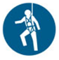 |  |  |  |  |  | Other mandatory site PPE as advised by Client or PC.

- PERMITS, TICKETS OR LICENCES REQUIRED TO PERFORM WORK
Role / Task | Training, Permit, Ticket or Licence
Workers | Company Induction, General Construction Induction
Working from over 2 m | General Work from Heights training
Use of Fall Arrest Equipment | Use and safety measures for equipment
Crane Operators/Riggers/Doggers | CV - Vehicle loading crane. | CN - Non-slewing mobile crane | C2 - Slewing mobile crane 20 tonne
Crane Operators/Riggers/Doggers | C6 - Slewing mobile crane 60 tonne | C1 - Slewing mobile crane 100 tonne | C0 - Slewing mobile crane >100 tonne
Crane Operators/Riggers/Doggers | RB - Rigging- Basic | RI - Rigging- Intermediate | RA - Rigging- Advanced
Crane Operators/Riggers/Doggers | DG - Dogger
6 and 12 monthly Inspection of Travel restraint systems | Height Safety Equipment Inspector

- PLANT AND EQUIPMENT
Plant and Equipment Description | Maintenance / Checks / Tests | Plant and Equipment Description | Maintenance / Checks / Tests
Reflective vests, communication devices. | Checked before use to ensure they are in good working condition. | Relevant signage and barricading as required. | Checked regularly to ensure they remain effective.
Fall arrest equipment | Visually inspected before use.  Tested as per manufacturer’s instructions.

- CHEMICALS
Chemical Name | Hazardous? | SDS Attached | Controls
 | Yes No | Yes No | As per Safety Data Sheet
 | Yes No | Yes No | As per Safety Data Sheet
 | Yes No | Yes No | As per Safety Data Sheet
 | Yes No | Yes No | As per Safety Data Sheet

- LEGISLATION AUSTRALIAN STANDARDS AND CODES OF PRACTICE TO BE COMPLIED WITH
QUEENSLAND | NATIONAL
Work Health and Safety Act 2011 | AS 1353.2-1997 Flat synthetic-webbing slings – Care and use
Work Health and Safety Regulation 2011 | AS 1418.1-2002/Amdt 1-2004 Cranes, hoists and winches—General requirements
How to Manage Work Health and Safety Risks Code of Practice 2011 | AS 1418.5-2013 Cranes, hoists and winches—Mobile cranes
Hazardous Manual Tasks Code of Practice 2011 | AS 2550.1-2011 Cranes, hoists and winches – Safe use – General Requirements
Mobile Crane Code of Practice 2006 | AS 2550.5-2016 Cranes, hoists and winches – Safe use – Mobile cranes
Managing Risks of Plant in the Workplace Code of Practice 2013 | AS 2759-2004 Steel wire rope – Use, operation and maintenance
Traffic Management for Construction or Maintenance Work 2008 | AS 3775.1:2014/Amdt 2:2015 Chain slings for lifting purposes - Grade T(80) and V(100) - Product specification
WHS Consultation, Co-operation and Co-ordination Code of Practice 2011 | AS 3775.2:2014/Amdt 1:2015 Chain slings for lifting purposes - Grade T(80) and V(100) - Care and use
Electrical Safety Code of Practice 2010 – Work near Overhead and Underground Electric Lines | AS 4497.2-1997 Round slings – Synthetic fibre – Care and use

- WORK RISKS AND CONTROLS
Item No. | Job Procedure in Steps | Possible Health, Safety and Environmental Hazards/ Risks | Risk Score Before | Health, Safety and Environmental Controls | Risk Score After | Person(s) Responsible
 | Pre-start | Workers not understanding risk controls | E 80 | Pre-start meeting with workers to discuss requirements of this SWMS.  Feedback will be requested from workers.  All workers to sign off accordingly. | M 52 | Site Supervisor
 | Site preparation | Plant striking persons or objects | E 72 | Barricade out and around areas where materials are being lifted and loaded.  Make sure people are out well out of the loading area. | M 52 | Worker  Site Supervisor
 | Determining crane suitability | Failure of crane | E 72 | The following factors should be considered when selecting the right crane for the task:  - Capacity of the crane (SWL);  - Highest lift required;  - Longest lift required;  - Dimensions of the crane (without riggers extended) and accessibility at the site. | M 52 | Contractor
 | Crane operator | Incompetent persons performing tasks | E 80 | Any cranes required for work will be sourced and operated by an external provider.  It is expected that the crane operator will:  - Be licensed and competent to complete the job;  - Conduct and record a pre-start check;  - Establish that the crane is in good condition and suitable for the task;  - Never use any equipment that is faulty (including crane, sling or shackle);  - Ensure crane has a fully-charged fire extinguisher;  - Ensure crane is set up on stable ground;  - Ensure out-riggers are extended and packed (supported) according to the manufacturer’s instructions;  - Determine the lifting capacity of the crane from the Lift Chart;  - Determine the weight of the load to be lifted and ensure the capacity of the crane (in relation to extension) is not exceeded (Weight of items can be determined by markings, packing slips or by contacting suppliers.);  - Ensure the crane’s safe working load is not exceeded;  - Consider overhead obstacles and observe relevant exclusion zones; and  - Ensure there is adequate visibility or communication (via radio or hand-signals) with Dogman. | M 52 | Contractor
 | Movement of crane | Plant striking persons or objects  Noise | E 80 | Follow SWMS Work Involving Movement of Mobile Plant and SWMS Work near Roads | M 52 | Worker  Site Supervisor  Contractor
 | Set up crane | Contact with live electrical conductor | E 80 | Identify overhead powerlines.  Follow SWMS Work Near Power Lines | M 52 | Worker  Site Supervisor  Contractor
 |  | Crane rollover | E 72 | Set crane up on level, stable ground.  Ensure out-riggers are extended and packed (supported) as per the manufacturer’s instructions. | M 48 | Worker  Site Supervisor  Contractor
 |  | Blocking emergency access | E 72 | Prior to setting up for lifts check that access is not denied for emergency services. | M 52 | Worker  Site Supervisor  Contractor
 |  | Lightning | H 60 | Do not operate outdoor cranes during a storm, when lightning strikes could be reasonably expected. | L 40 | Worker  Site Supervisor  Contractor
 |  | Wind | E 72 | Where it is necessary to lift loads with a large wind-catching surface, the lift shall be assessed taking full consideration of the effect of the wind. Assessment shall consider the effects of wind gusts and their effect on the crane’s stability.  An anemometer should be available at the site to provide an accurate wind speed reading. Where wind speed exceeds, manufacturer’s operating recommendations, the crane shall be placed out of service. | L 40 | Worker  Site Supervisor  Contractor
 |  | Wet conditions | E 72 | Brakes or clutch units and electrical equipment shall be protected from the ingress of water. Following shutdown, and before starting hoisting operations, all friction brakes and clutches shall be carefully tested. | L 40 | Worker Contractor
 | Loading the crane | Falling from heights | E 72 | Loading of the crane should be undertaken by qualified Riggers and Doggers.  If landing a load above 2 m the dogman/rigger must wear fall arrest harness and be hooked to proper anchor point.  Follow SWMS Work at Heights: Using Fall Arrest Systems | M 52 | Worker Contractor
 |  | Failure of rigging equipment | E 80 | Use proper lifting points when slinging load.  Check for any damage and testing/tagging compliance on lifting/rigging equipment.  NO CURRENT TAG ON GEAR - DO NOT USE!  Check safe work capacities and all lifting gear are within Safe Working Load recommendations. | M 52 | Worker  Site Supervisor  Contractor
 | Raising the load | Falling objects  Damage to load  Object striking people/ objects | E 80 | Never raise loads over people, occupied vehicles or buildings.  Under no circumstances is anyone permitted to be raised on or ride on, hooks, slings or loads.  Never drag a load.  Always use lifting equipment in the manner which it was designed to be used.  Stay clear of load and use tag lines at all times.  Make sure hoist rope is in vertical position before lifting  Proper communications to be in place before lift commences - i.e. two-way radio, hand signals or whistles.  Consider hoist and slewing speed and centre of gravity of load before lift commences. | M 52 | Worker  Site Supervisor  Contractor
 | Lowering of load | Contact with overhead power lines  Falling objects | E 80 | Make sure the landing area is prepared to receive the load.  Attach tag lines to load to help land load safely.  At all times, overhead powerlines are to be considered while lift is in progress. | M 52 | Worker  Site Supervisor  Contractor
 | Site Emergency | Poor or delayed response in the case of emergency | E 80 | Site specific emergency procedures will be followed at all times. | L 40 | Worker  Site Supervisor

- RISK ASSESSMENT TOOL
RISK MATRIX |  |  |  |  |  |  |  |  | HIERARCHY OF CONTROLS
LIKELIHOOD |  |  | CONSEQUENCE |  |  |  |  |  | 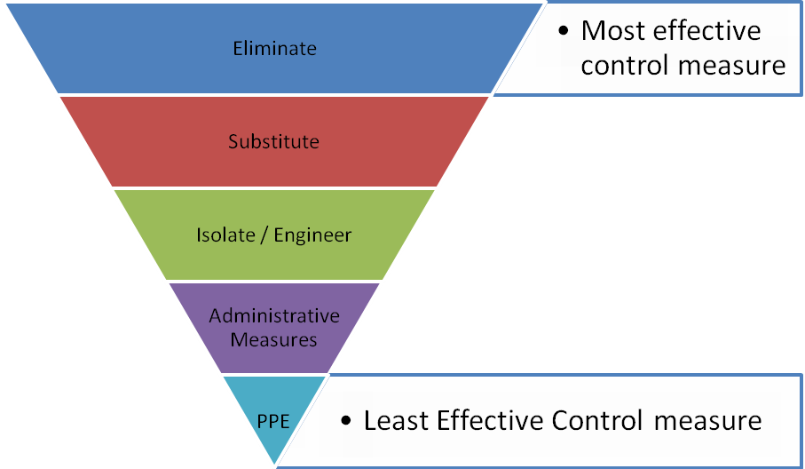
 |  |  | 1 |  | 2 | 3 | 4 | 5
 |  |  | Insignificant |  | Minor | Moderate | Major | Catastrophic
A. | Almost certain |  | M 52 |  | H 64 | E 76 | E 88 | E 100
B. | Likely |  | M 44 |  | H 56 | H 68 | E 80 | E 92
C. | Possible |  | L 36 |  | M 48 | H 60 | E 72 | E 84
D. | Unlikely |  | L 28 |  | L 40 | M 52 | H 64 | E 76
E. | Rare |  | L 20 |  | L 32 | M 44 | H 56 | H 68
SCORE INDICATOR
SCORE |  | LEVEL OF DANGER |  | REQUIRED ACTION
72 – 100 |  | EXTREME |  | NO WORK SHOULD COMMENCE AT THIS LEVEL!  This is an unacceptable level of risk. A review of controls must be performed to reduce risk as low as reasonably practicable. If risk cannot be further reduced, a Permit System must be applied. The permit must be available at all times work is being performed, signed by both the workers, a senior management representative and the Client (if applicable) to ensure that the risk is reduced as far as practicable.
56 – 68 |  | HIGH |  | WORK CAN COMMENCE AT THIS LEVEL IF THE CONTROL MEASURES ARE APPROVED BY THE PROJECT MANAGER OR DELEGATE  The Project Manager or delegate will review existing controls to ensure that the risk is reduced to as low as is reasonably practicable.
44 – 52 |  | MODERATE |  | WORK CAN COMMENCE WITH CONTROL MEASURES IN PLACE.  Management must monitor and review the controls to ensure controls are adequately used, do not present further hazards / risks and aim to reduce the risk further if practicable.
20 - 40 |  | LOW |  | REVIEW IF CHANGES OCCUR.  Record and review if any equipment, people, materials, work processes, or procedures change.

- MONITORING AND REVIEW OF CONTROL MEASURES
Pre-Start | Pre-start meetings are held to review control measures and ensure workers are aware of controls.
Ongoing Monitoring | Site Supervisor will continually monitor works against the controls stated in this safe work method statement. The Health and Safety Checklist is used to document formal inspections of the works and work area.
Annual | This safe work method statement is reviewed annually or as required.
NON-CONFORMANCE | Should any aspect of this SWMS not be complied with, work affected by the non-compliance must cease. The Site Supervisor will either enforce the controls as stated by the SWMS or, where appropriate, review the SWMS in consultation with workers and update with more suitable controls provided the revised controls still ensure that the hazards / risks are controlled as far as reasonably practicable.

- SWMS CONSULTATION AND SIGN-OFF RECORD
I confirm, by signing below, that I have read and understand the requirements of this SWMS, that I agree that the SWMS is acceptable for the proposed work, and I agree to abide by the requirements. If the work conditions change, or additional hazards are identified, these changes shall be discussed, the SWMS modified and signed again.
ISSUE | NAME (Please Print) | SIGNATURE | ISSUE | NAME (Please Print) | SIGNATURE
A
A
A
A
A
A
A
A
A
A
A
A
A
A
A
A
A

