SWMS 113 – WORK INVOLVING LIVE TESTING AND FAULT FINDING
NOTE: This industry standard SWMS template has been made accessible by Breffni Ceilings & Partitions Pty Ltd, to be used as a guide only. The sub-contractor/user is entirely responsible for its contents at the point of submission. Therefore, please ensure that every section is reviewed and personalised in full.

- PROJECT DETAILS
Project Name: |  | Project Address:
Client / Principal Contractor:
Description of Work (Scope):
High Risk Construction Work: | Work near an exposed energy source
Date Work is to Commence: |  | Approx. Duration of Work:
Person Responsible for Monitoring Activity: |  | Name:
Date Created: |  | Issue: | A

- CONSULTATION
THIS SWMS HAS BEEN DEVELOPED IN CONSULTATION WITH THE FOLLOWING WORKERS: |  |  |  | SWMS PROVIDED TO CLIENT / PRINCIPAL CONTRACTOR
Issue: | Name: | Position: | Date: | Issue: | Name: | Position: | Date:
A |  |  |  | A

- APPROVAL
 | APPROVED BY | REVIEWED PRIOR TO WORK COMMENCING  (Principal Contractor Representative) | REVIEWED ON SITE PRIOR TO COMMENCING WORK  (Site Supervisor)
NAME
SIGNATURE
DATE

- PERSONAL PROTECTIVE EQUIPMENT
Uniform | Footwear | High Vis’ | Safety Helmet | Protective Eyewear | Face Shield | Fall Arrest | Gloves | Hearing | Dust Mask | Respirator | Other | PPE. Notes (e.g. P2 Dust Mask, etc.)
 |  |  |  |  |  | 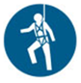 |  |  |  |  |  | Other mandatory site PPE as advised by Client or PC.

- PERMITS, TICKETS OR LICENCES REQUIRED TO PERFORM WORK
Role / Task | Training, Permit, Ticket or Licence
Workers | Company Induction, General Construction Induction
Working on or near live installations: | LV Switchboard rescue
 | Electrical Licence – Class:
 | Current CPR Qualifications:

- PLANT AND EQUIPMENT
Plant and Equipment Description | Maintenance / Checks / Tests | Plant and Equipment Description | Maintenance / Checks / Tests
LV Electrical Rescue kit | Visually inspect before use – remove and replace damaged equipment
Appropriate testing equipment | If they cannot be visually confirmed as being correctly functioning and safe the instruments should be tested at least every 6 months to ensure it is in proper working order.
Safety glasses/ Insulated gloves, long sleeved shirts and long pants (cotton) | Checked before use by worker to ensure they are in good condition.

- CHEMICALS
Chemical Name | Hazardous? | SDS Attached | Controls
 | Yes No | Yes No | As per Safety Data Sheet
 | Yes No | Yes No
 | Yes No | Yes No
 | Yes No | Yes No

- LEGISLATION AUSTRALIAN STANDARDS AND CODES OF PRACTICE TO BE COMPLIED WITH
QUEENSLAND | NATIONAL
Work Health and Safety Act 2011 | AS/NZS 3000:2007/Amdt 2:2012 Electrical Installations (known as the Australian/New Zealand Wiring Rules)
Work Health and Safety Regulation 2011 | AS/NZS 3012:2010/Amdt 1:2015 Electrical Installations – Construction and demolition sites
Electrical Safety Act 2002 (Qld) | AS/NZS 3760:2010/Amdt 2:2012 In-service safety inspection and testing of electrical equipment
Electrical Safety Regulation 2013 (Qld) | AS/NZS 4836:2011/Amdt 1:2017 Safe working on or near low-voltage electrical installations and equipment
How to Manage Work Health and Safety Risks Code of Practice 2011 | AS/NZS 3017:2007 Electrical installations - Verification guidelines
Hazardous Manual Tasks Code of Practice 2011
Electrical Safety Code of Practice 2013 – Managing Electrical Risks in the Workplace
Electrical Safety Code of Practice 2010 – Works
Electrical Safety Code of Practice 2010 – Working Near Overhead and Underground Electric Lines
WHS Consultation, Cooperation and Coordination Code of Practice 2011

- WORK RISKS AND CONTROLS
Item No. | Job Procedure in Steps | Possible Health, Safety and Environmental Hazards/ Risks | Risk Score Before |  | Health, Safety and Environmental Controls | Risk Score After | Person(s) Responsible
 | Pre-start | Workers not understanding risk controls | E 80 |  | Pre-start meeting with workers to discuss requirements of this SWMS.  Feedback will be requested from workers.  All workers to sign off accordingly. | M 52 | Site Supervisor
 | Choosing workers | Workers not being competent |  | E 72 | Persons performing testing will:  - Hold current Queensland Electrical Licence; and  - Hold current CPR training (valid for 6 months); and  - Switchboard rescue qualification (valid for 6 months); and  - Be authorised to carry out the work. | L 40 | Worker  Site Supervisor
 | Visual inspection | Hazards and risks not being properly identified |  | E 72 | The visual inspection shall be carried out before, or in association with testing, and should where practicable be made before the relevant part of the electrical installation is placed in service. | L 40 | Worker
 | Preparing to complete testing | Contact with live exposed electrical parts |  | E 80 | Live parts not involved in the testing activity covered for safety.  Before testing, the effects of the following will be considered:  - Bridging out of safety and control interlocks;  - Inadvertent initiation of equipment operation;  - Inadvertent energisation of equipment;  - Bridging of terminals;  - Forcing of contactors and interlocks;  - Forcing of software interlocks. | M 52 | Worker
 | Using test equipment | Failure of test equipment  Unsuitability of test equipment |  | E 80 | Only approved test equipment appropriate for the job will be used. Test equipment will be checked prior to use to ensure it is in correct working order.  Instrument checked to ensure it is suitable for prospective fault current, is in-test and the leads are in a satisfactory condition.  Tools checked to ensure insulation is complete and in good condition.  RCD used on supply for equipment connected by a plug and socket. | M 52 | Worker  Site Supervisor
 | Working around the public/other trades | Injury to member of the public/other trades |  | E 72 | Install barriers to prevent access by the general public or other trades.  If barriers are not practical a Safety Observer will be in attendance to warn others of possible dangers. | L 40 | Worker
 | Working in close proximity to live parts (electrical) | Exposure to live terminals |  | E 80 | Ensure all hand tools are insulated and in good condition.  Use appropriate test equipment.  Eye protection is to be worn.  Remove metallic jewellery or body piercing when conducting test.  Non-flammable clothing with long sleeves and long trousers worn in high fault current situations or in a close testing environment.  Shirts must be buttoned closed and sleeves rolled down to cover any exposed parts of the body. Insulating gloves are also used. Eye protection may be required.  Insulating mat used in a close situation, damp situations or when high fault currents exist.  Fit insulated covers or barriers. | M 52 | Worker
 | Appointment of an observer | Working in isolation/alone |  | E 80 | Safety Observer is required unless the risk assessment does not show there is a high risk to electrical safety in performing the testing of the electrical equipment i.e. if high fault currents exist at the work site. | M 52 | Worker
 | Role of a safety observer | Injury resulting from being unaware of dangers |  | E 72 | Clearly communicate and understand the safety observer's role.  The safety observer will not carry out any other work or function that compromises their role as a safety observer.  The safety observer will be competent in observing, warning and communicating effectively (this may mean the use of electronic communications, e.g. a two-way radio).  The safety observer will be hazard and risk aware.  A safety observer will have the authority and ability to stop the work before the risks become too high.  A safety observer will not be situated in the work basket or elevating work platform.  The safety observer will be competent to help with the electrical work.  The safety observer will be competent in isolation techniques and aware of isolation points.  The safety observer will not observe more than one task at a time.  The safety observer should be competent to:  - Rescue the person performing the electrical work; and  - Provide resuscitation (assessed in the last 12 months); and  - Be able to provide assistance in emergencies. | L 40 | Worker  Site Supervisor
 | Site Emergency | Poor or delayed response in the case of emergency |  | E 80 | Site specific emergency procedures will be followed at all times. | L 40 | Worker  Site Supervisor

- RISK ASSESSMENT TOOL
RISK MATRIX |  |  |  |  |  |  |  |  | HIERARCHY OF CONTROLS
LIKELIHOOD |  |  | CONSEQUENCE |  |  |  |  |  | 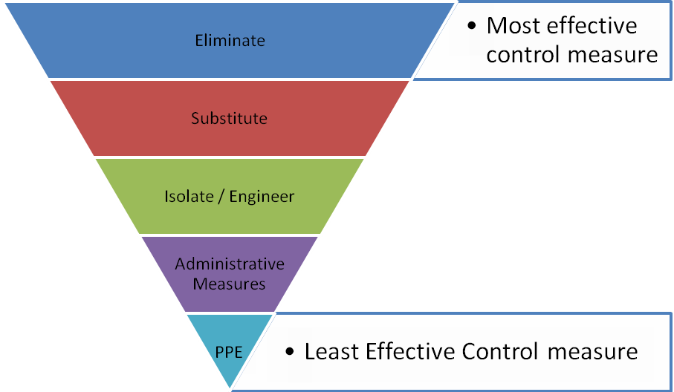
 |  |  | 1 |  | 2 | 3 | 4 | 5
 |  |  | Insignificant |  | Minor | Moderate | Major | Catastrophic
A. | Almost certain |  | M 52 |  | H 64 | E 76 | E 88 | E 100
B. | Likely |  | M 44 |  | H 56 | H 68 | E 80 | E 92
C. | Possible |  | L 36 |  | M 48 | H 60 | E 72 | E 84
D. | Unlikely |  | L 28 |  | L 40 | M 52 | H 64 | E 76
E. | Rare |  | L 20 |  | L 32 | M 44 | H 56 | H 68
SCORE INDICATOR
SCORE |  | LEVEL OF DANGER |  | REQUIRED ACTION
72 – 100 |  | EXTREME |  | NO WORK SHOULD COMMENCE AT THIS LEVEL!  This is an unacceptable level of risk. A review of controls must be performed to reduce risk as low as reasonably practicable. If risk cannot be further reduced, a Permit System must be applied. The permit must be available at all times work is being performed, signed by both the workers, a senior management representative and the Client (if applicable) to ensure that the risk is reduced as far as practicable.
56 – 68 |  | HIGH |  | WORK CAN COMMENCE AT THIS LEVEL IF THE CONTROL MEASURES ARE APPROVED BY THE PROJECT MANAGER OR DELEGATE  The Project Manager or delegate will review existing controls to ensure that the risk is reduced to as low as is reasonably practicable.
44 – 52 |  | MODERATE |  | WORK CAN COMMENCE WITH CONTROL MEASURES IN PLACE.  Management must monitor and review the controls to ensure controls are adequately used, do not present further hazards / risks and aim to reduce the risk further if practicable.
20 - 40 |  | LOW |  | REVIEW IF CHANGES OCCUR.  Record and review if any equipment, people, materials, work processes, or procedures change.

- MONITORING AND REVIEW OF CONTROL MEASURES
Pre-Start | Pre-start meetings are held to review control measures and ensure workers are aware of controls.
Ongoing Monitoring | Site Supervisor will continually monitor works against the controls stated in this safe work method statement. The Health and Safety Checklist is used to document formal inspections of the works and work area.
Annual | This safe work method statement is reviewed annually or as required.
NON-CONFORMANCE | Should any aspect of this SWMS not be complied with, work affected by the non-compliance must cease. The Site Supervisor will either enforce the controls as stated by the SWMS or, where appropriate, review the SWMS in consultation with workers and update with more suitable controls provided the revised controls still ensure that the hazards / risks are controlled as far as reasonably practicable.

- SWMS CONSULTATION AND SIGN-OFF RECORD
I confirm, by signing below, that I have read and understand the requirements of this SWMS, that I agree that the SWMS is acceptable for the proposed work, and I agree to abide by the requirements. If the work conditions change, or additional hazards are identified, these changes shall be discussed, the SWMS modified and signed again.
ISSUE | NAME (Please Print) | SIGNATURE | ISSUE | NAME (Please Print) | SIGNATURE
A
A
A
A
A
A
A
A
A
A
A
A
A
A
A
A

