SWMS 114 –WORKING ON AN ENERGISED ELECTRICAL INSTALLATION
NOTE: This industry standard SWMS template has been made accessible by Breffni Ceilings & Partitions Pty Ltd, to be used as a guide only. The sub-contractor/user is entirely responsible for its contents at the point of submission. Therefore, please ensure that every section is reviewed and personalised in full.

- PROJECT DETAILS
Project Name: |  | Project Address:
Client / Principal Contractor:
Description of Work (Scope):
High Risk Construction Work: | Work near an exposed energised electrical installation, an activity which reasonably may result in death or bodily harm.
Date Work is to Commence: |  | Approx. Duration of Work:
Person Responsible for Monitoring Activity: |  | Name:
Date Created: |  | Issue: | A

- CONSULTATION
THIS SWMS HAS BEEN DEVELOPED IN CONSULTATION WITH THE FOLLOWING WORKERS: |  |  |  | SWMS PROVIDED TO CLIENT / PRINCIPAL CONTRACTOR
Issue: | Name: | Position: | Date: | Issue: | Name: | Position: | Date:
A |  |  |  | A

- APPROVAL
 | APPROVED BY | REVIEWED PRIOR TO WORK COMMENCING  (Principal Contractor Representative) | REVIEWED ON SITE PRIOR TO COMMENCING WORK  (Site Supervisor)
NAME
SIGNATURE
DATE

- PERSONAL PROTECTIVE EQUIPMENT
Uniform | Footwear | High Vis’ | Safety Helmet | Protective Eyewear | Face Shield | Fall Arrest | Gloves | Hearing | Dust Mask | Respirator | Other | PPE. Notes (e.g. P2 Dust Mask, etc.)
 |  |  |  |  |  | 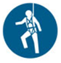 |  |  |  |  |  | Other mandatory site PPE as advised by Client or PC.  Linesman gloves for 240V work

- PERMITS, TICKETS OR LICENCES REQUIRED TO PERFORM WORK
Role / Task | Permit, Ticket or Licence
Workers | Company Induction, General Construction Induction
Working on or near live installations: | LV Switchboard rescue
 | Electrical Licence – Class:
 | Current CPR Qualifications:
 | Safety Observer

- PLANT AND EQUIPMENT
Plant and Equipment Description | Maintenance / Checks / Tests | Plant and Equipment Description | Maintenance / Checks / Tests
LV Electrical Rescue kit | Visually inspect before use – remove and replace damaged equipment
Appropriate testing equipment | If they cannot be visually confirmed as being correctly functioning and safe the instruments should be tested at least every 6 months to ensure it is in proper working order.
Safety glasses/ Insulated gloves, long sleeved shirts and long pants (cotton) | Checked before use by worker to ensure they are in good condition.

- CHEMICALS
Chemical Name | Hazardous? | SDS Attached | Controls
 | Yes No | Yes No | As per Safety Data Sheet
 | Yes No | Yes No
 | Yes No | Yes No
 | Yes No | Yes No

- LEGISLATION AUSTRALIAN STANDARDS AND CODES OF PRACTICE TO BE COMPLIED WITH
QUEENSLAND | NATIONAL
Work Health and Safety Act 2011 | AS/NZS 3017:2007 Electrical installations - Verification guidelines
Work Health and Safety Regulation 2011 | AS/NZS 3012:2010/Amdt 1:2015 Electrical Installations – Construction and demolition sites
Electrical Safety Code of Practice 2013 – Managing Electrical Risks in the Workplace | AS/NZS 3000:2007/Amdt 2:2012 Electrical Installations (known as the Australian/New Zealand Wiring Rules)
Electrical Safety Code of Practice 2010 – Working Near Overhead and Underground Electric Lines | AS/NZS 3760:2010/Amdt 2:2012 In-service safety inspection and testing of electrical equipment
Electrical Safety Act 2002 (Qld) | AS/NZS 4836:2011/Amdt 1:2017 Safe working on or near low-voltage electrical installations and equipment
Electrical Safety Regulation 2013 (Qld)
How to Manage Work Health and Safety Risks Code of Practice 2011
Hazardous Manual Tasks Code of Practice 2011
Electrical Safety Code of Practice 2010 – Works
Electrical Safety Code of Practice 2010 – Electrical Equipment Rural Industry
WHS Consultation, Cooperation and Coordination Code of Practice 2011

- WORK RISKS AND CONTROLS
Item No. | Job Procedure in Steps | Possible Health, Safety and Environmental Hazards/ Risks | Risk Score Before | Health, Safety and Environmental Controls | Risk Score After | Person(s) Responsible
 | Pre-start | Workers not understanding risk controls | E 80 | Pre-start meeting with workers to discuss requirements of this SWMS.  Feedback will be requested from workers.  All workers to sign off accordingly. | M 52 | Site Supervisor
 | Deciding on live work | Electrocution  Serious bodily injury  Death | E 92 | Working live shall be considered as “a Last Resort”. Alternatives such as shut-down, after- hours shut-down etc. should be considered. Live work will only be considered when there are safety concerns or where the shut-down of power will cause major disruption to services. Economic reasons are not considered an adequate reason to work live. | L 40 | Site Supervisor
 | Appointment of an observer | Injury resulting from being unaware of dangers | E 80 | Persons involved in live work or appointed as observers must:  - Hold current Queensland Electrical Licence; and  - Hold current CPR training (valid for 12 months); and  - Switchboard rescue qualification (valid for 12 months); and  - Be competent to carry out the task; and  - Be authorised to carry out the work.  The role of the Safety Observer is to warn the worker of danger as well as to perform rescue and resuscitation. Therefore, the Observer cannot carry out any other duties that could distract him/her from their appointed role.  Communication (verbal and visual) between the worker and Observer must be maintained.  The Safety Observer has the authority to stop the work if they believe the situation is dangerous. | M 52 | Site Supervisor
 | Before work starts | Electrocution  Serious bodily injury  Death | E 92 | Remove ALL jewellery, including metal framed glasses, prior to starting work.  Before commencing live work ensure:  - The PERMIT TO PERFORM LIVE ELECTRICAL WORK is completed and authorised;  - Appropriate protective clothing is worn and PPE is available and in good condition;  - Safety observer with current CPR and live rescue qualification is present at all times;  - LV Electrical Rescue Kit is at the working site, has been checked and is in date;  - Evacuation lighting is working and adequate;  - Isolation point for supply is known and identified by signage;  - Live conductors are insulated to prevent inadvertent contact or flashover. | M 52 | Worker  Site Supervisor
 |  | Trips, slips, falls | H 60 | Ensure there is a clear work area, free from obstruction, with clear entry and emergency exits available. | L 40 | Worker
 |  | Fire/explosion | E 84 | Ensure fire-fighting equipment (suitable for electrical fires) is accessible. | M 52 | Worker  Site Supervisor
 |  | Injury to the public | E 84 | Ensure unauthorised persons are excluded from worksite and signage/barriers are in place. | L 40 | Worker  Site Supervisor
 | Performing live work | Electrocution  Serious bodily injury  Death | E 92 | When plant and equipment, parts or devices are not to be used, the item or items should be made safe (e.g. isolated) and tagged out of service.  Use a safe system of work, turn the power off, and test before working on or near exposed live parts if applicable.  Ensure appropriate PPE is worn and isolation procedures to be followed.  Ensure workers are qualified and competent in completing the task. Experienced electrical worker to do disconnection, isolation, testing, and commissioning.  Ensure work is not performed by fatigued workers. Proceed with caution. | M 52 | Worker  Site Supervisor
 | Leaving unfinished work | Injury to the public or other workers and trades. | H 68 | Secure site with barriers and signs. Please refer to WI Signs and Barricades. Ensure unfinished work is clearly identified with out of service tags. Ensure there is a clear work area, free from obstruction, with clear entry and emergency exits available. | L 40 | Worker  Site Supervisor
 | Ensuring the working and surrounding environment is maintained and not disturbed. | Dust, Noise, Rubbish, Trip hazards, Spills, and Security. | E 72 | Minimise the noise at the source where possible. Notify other workers if you are going to use noisy equipment so that they can utilise their hearing protection.  Suppress dust with fine water spray/mist where possible. Advise neighbouring workers of possible dust generating activities.  Maintain a Clean, Clear and Safe Work Area, and free of rubbish causing hazards. Check pathways and entrances and remove unnecessary items. Barricade areas used for storage and ensure signage is mounted to detract unwanted people in work area. Refer to WI Signs and Barricades  Clean up spills immediately and alert public and other trades with signs and barricades. | L 36 | Worker  Site Supervisor
 | Site Emergency | Poor or delayed response in the case of emergency | E 80 | Site specific emergency procedures will be followed at all times. | L 40 | Worker  Site Supervisor

- RISK ASSESSMENT TOOL
RISK MATRIX |  |  |  |  |  |  |  |  | HIERARCHY OF CONTROLS
LIKELIHOOD |  |  | CONSEQUENCE |  |  |  |  |  | 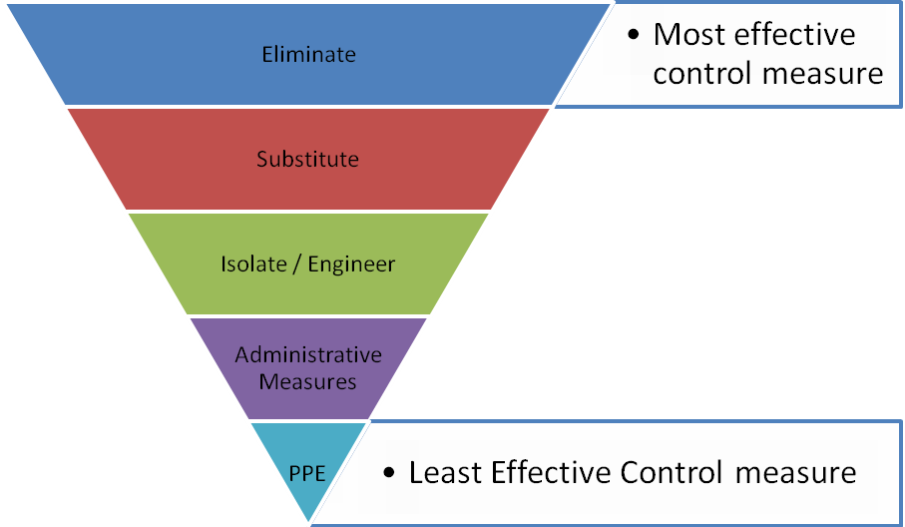
 |  |  | 1 |  | 2 | 3 | 4 | 5
 |  |  | Insignificant |  | Minor | Moderate | Major | Catastrophic
A. | Almost certain |  | M 52 |  | H 64 | E 76 | E 88 | E 100
B. | Likely |  | M 44 |  | H 56 | H 68 | E 80 | E 92
C. | Possible |  | L 36 |  | M 48 | H 60 | E 72 | E 84
D. | Unlikely |  | L 28 |  | L 40 | M 52 | H 64 | E 76
E. | Rare |  | L 20 |  | L 32 | M 44 | H 56 | H 68
SCORE INDICATOR
SCORE |  | LEVEL OF DANGER |  | REQUIRED ACTION
72 – 100 |  | EXTREME |  | NO WORK SHOULD COMMENCE AT THIS LEVEL!  This is an unacceptable level of risk. A review of controls must be performed to reduce risk as low as reasonably practicable. If risk cannot be further reduced, a Permit System must be applied. The permit must be available at all times work is being performed, signed by both the workers, a senior management representative and the Client (if applicable) to ensure that the risk is reduced as far as practicable.
56 – 68 |  | HIGH |  | WORK CAN COMMENCE AT THIS LEVEL IF THE CONTROL MEASURES ARE APPROVED BY THE PROJECT MANAGER OR DELEGATE  The Project Manager or delegate will review existing controls to ensure that the risk is reduced to as low as is reasonably practicable.
44 – 52 |  | MODERATE |  | WORK CAN COMMENCE WITH CONTROL MEASURES IN PLACE.  Management must monitor and review the controls to ensure controls are adequately used, do not present further hazards / risks and aim to reduce the risk further if practicable.
20 - 40 |  | LOW |  | REVIEW IF CHANGES OCCUR.  Record and review if any equipment, people, materials, work processes, or procedures change.

- MONITORING AND REVIEW OF CONTROL MEASURES
Pre-Start | Pre-start meetings are held to review control measures and ensure workers are aware of controls.
Ongoing Monitoring | Site Supervisor will continually monitor works against the controls stated in this safe work method statement. The Health and Safety Checklist is used to document formal inspections of the works and work area.
Annual | This safe work method statement is reviewed annually or as required.
NON-CONFORMANCE | Should any aspect of this SWMS not be complied with, work affected by the non-compliance must cease. The Site Supervisor will either enforce the controls as stated by the SWMS or, where appropriate, review the SWMS in consultation with workers and update with more suitable controls provided the revised controls still ensure that the hazards / risks are controlled as far as reasonably practicable.

- SWMS CONSULTATION AND SIGN-OFF RECORD
I confirm, by signing below, that I have read and understand the requirements of this SWMS, that I agree that the SWMS is acceptable for the proposed work, and I agree to abide by the requirements. If the work conditions change, or additional hazards are identified, these changes shall be discussed, the SWMS modified and signed again.
ISSUE | NAME (Please Print) | SIGNATURE | ISSUE | NAME (Please Print) | SIGNATURE
A
A
A
A
A
A
A
A
A
A
A
A
A
A
A
A

